EXP NO 1:

CREATE A SIMPLE CLOUD SOFTWARE APPLICATION AND PROVIDE IT AS A SERVICE USING ANY CLOUD SERVICE PROVIDER TODEMONSTRATE SOFTWARE AS A SERVICE (SAAS).

AIM:

To create a simple cloud software application and provide it as a service using any cloud service provider to demonstrate software as a service (saas).

PROCEDURE:

STEP1: GOTO ZOHO.COM

STEP 2: LOGIN TO THE ZOHO.COM

STEP 3: SELECT ONE APPLICATION

STEP 4: ENTER APPLICATION NAME

STEP 5: CREATED NEW APPLICATION

STEP 6: SELECT ONE FORM

STEP 7: THE SOFTWARE HASE BEEN CREATED

Here I created a simple cloud software application named hospital management system.

NEW APPOINTMENT FORM:

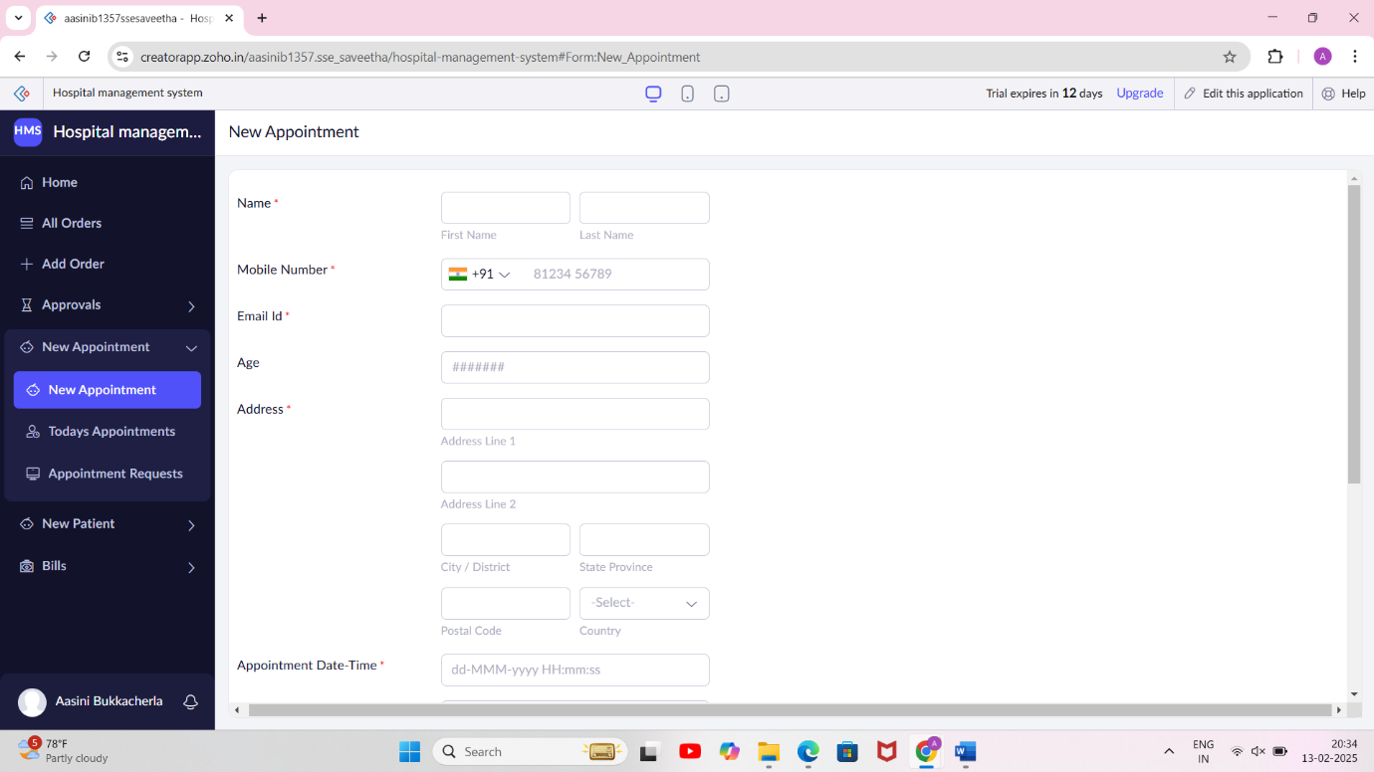

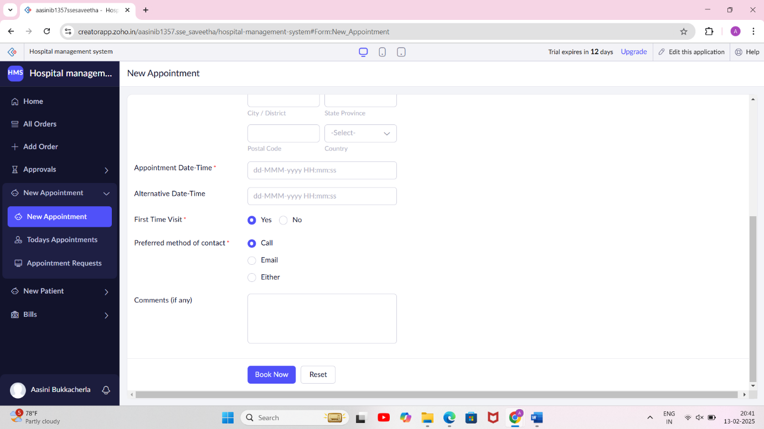

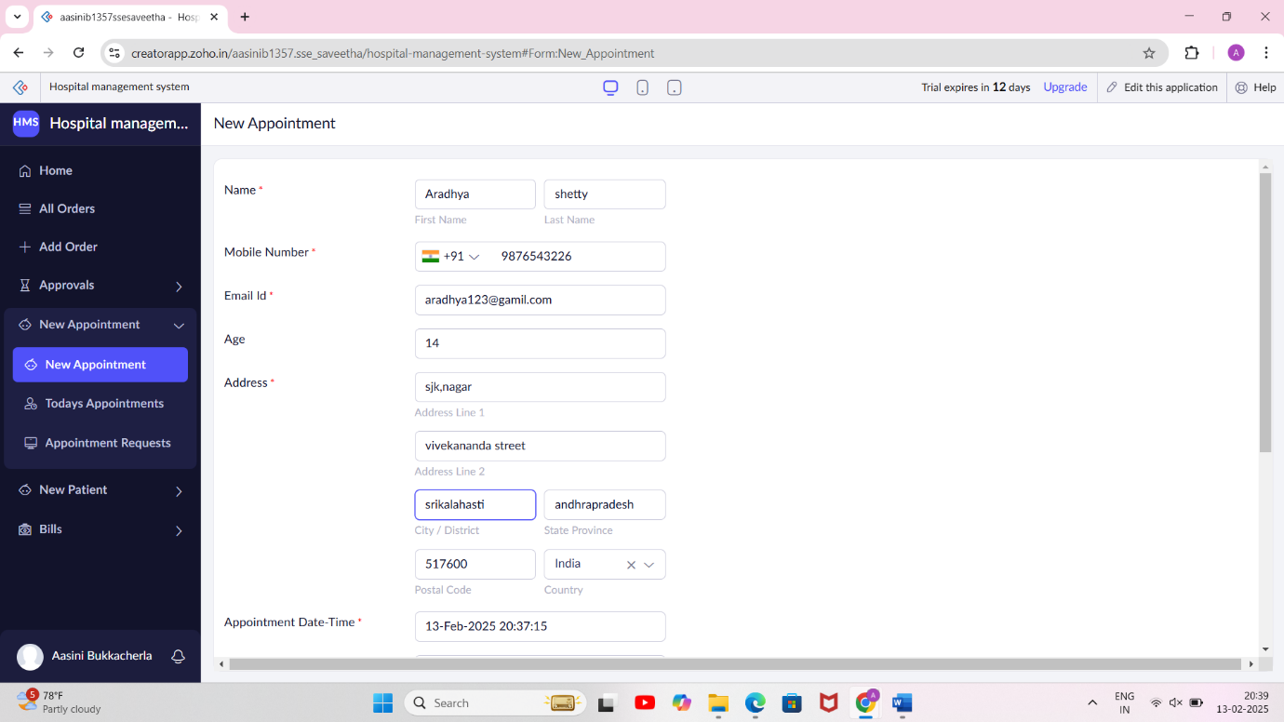

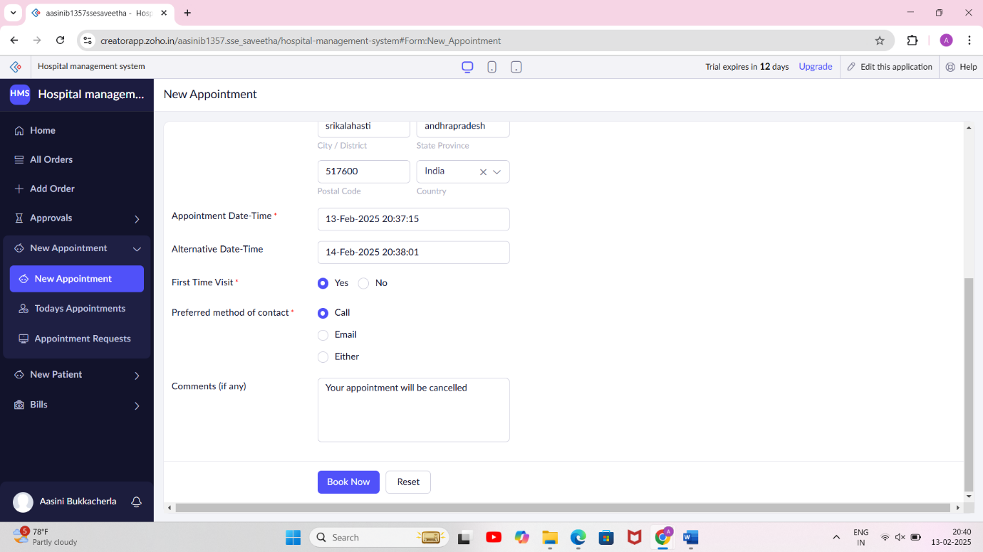

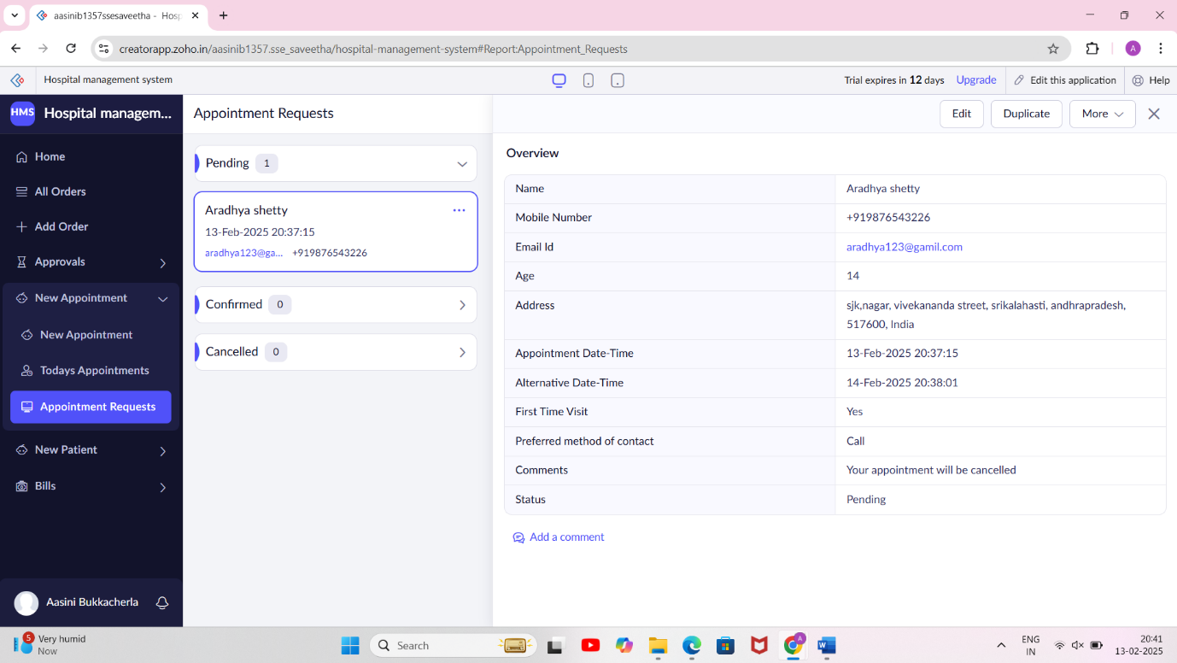

NEW PATIENT DETAILS FORM:

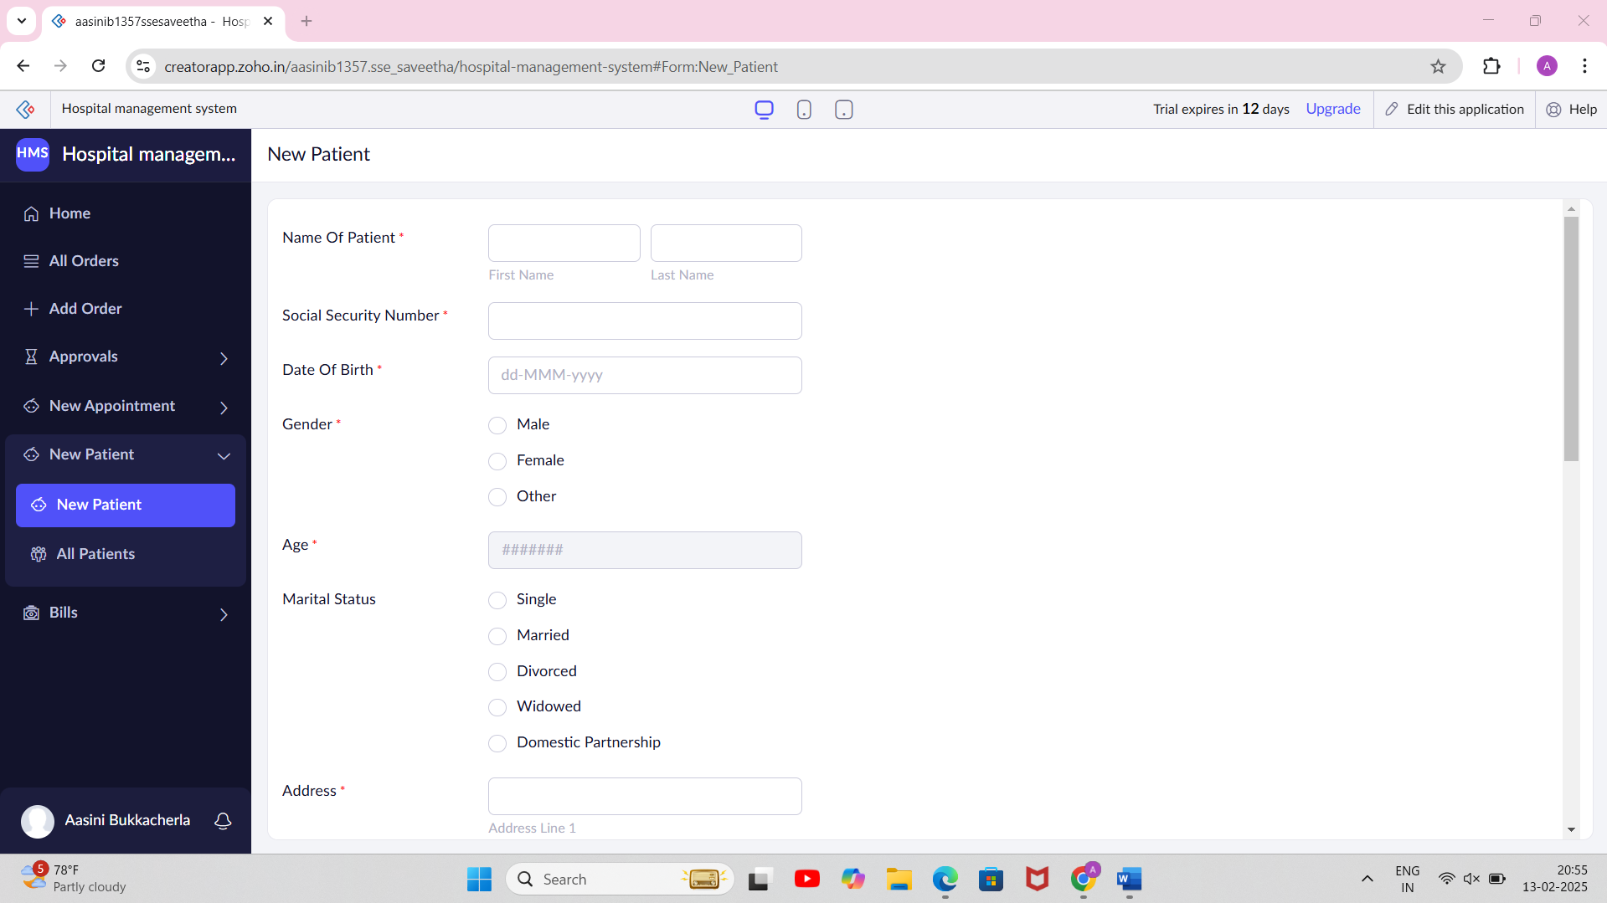

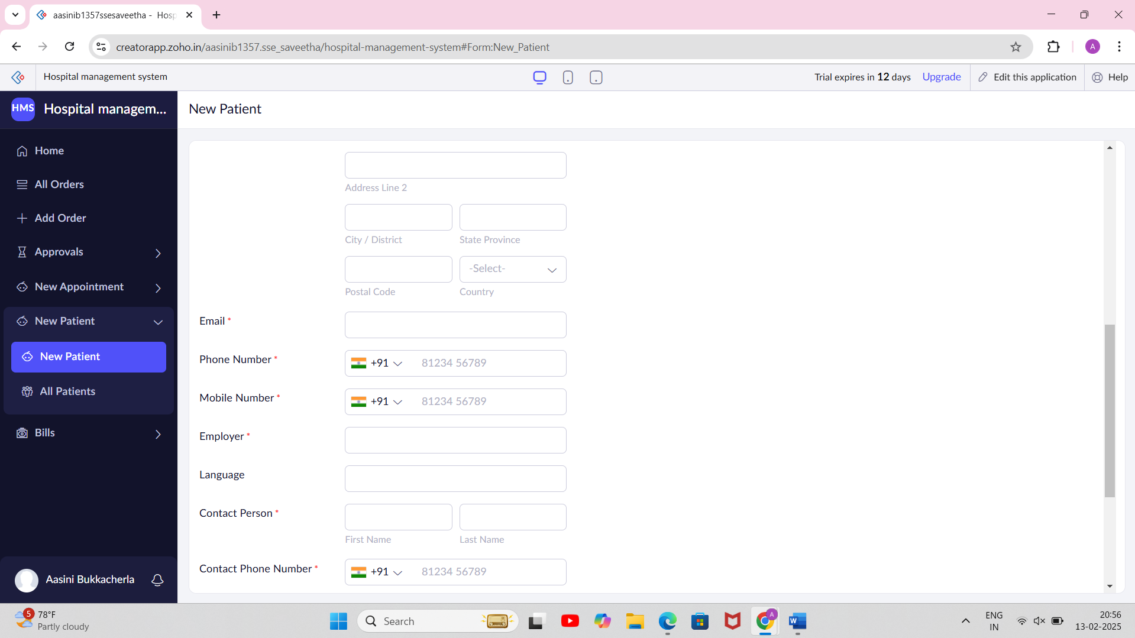

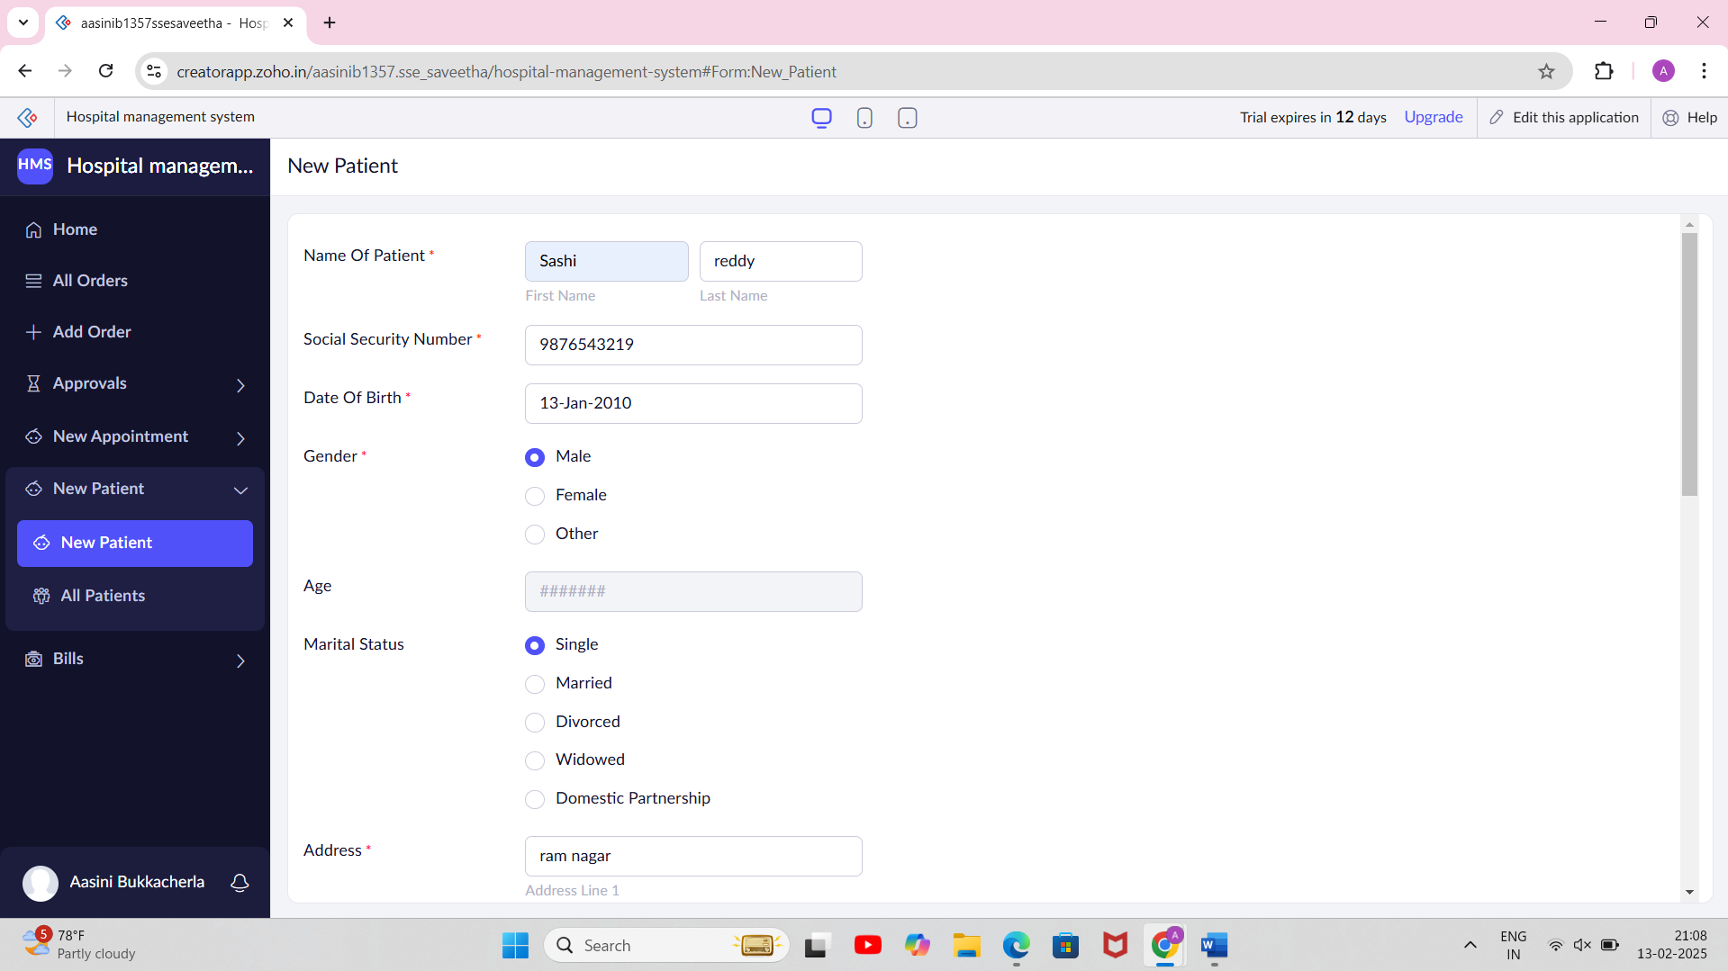

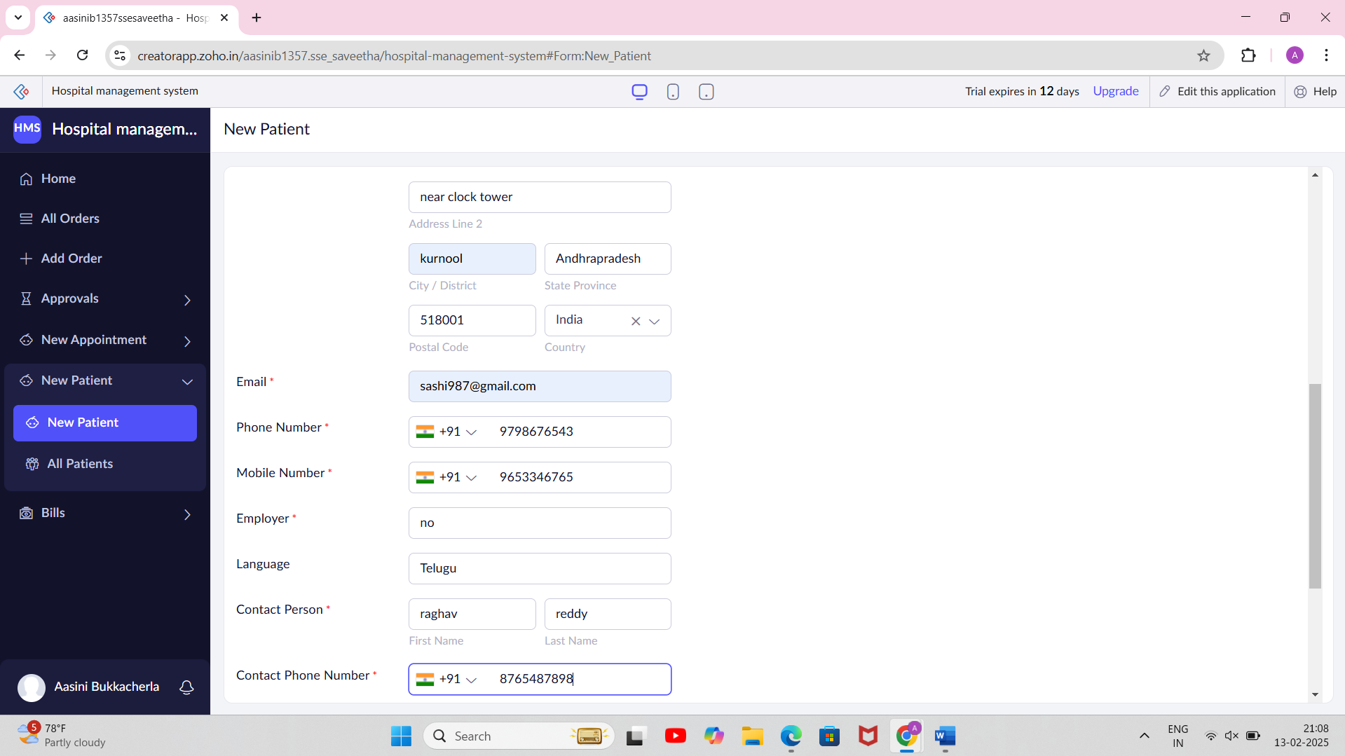

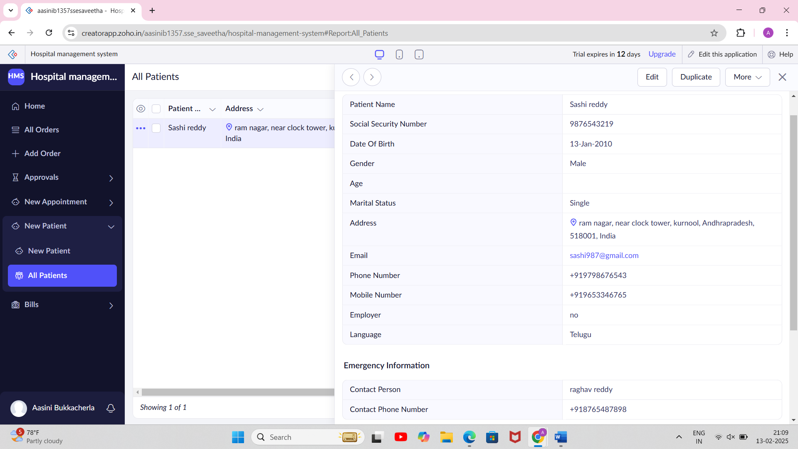

BILLS FORM:

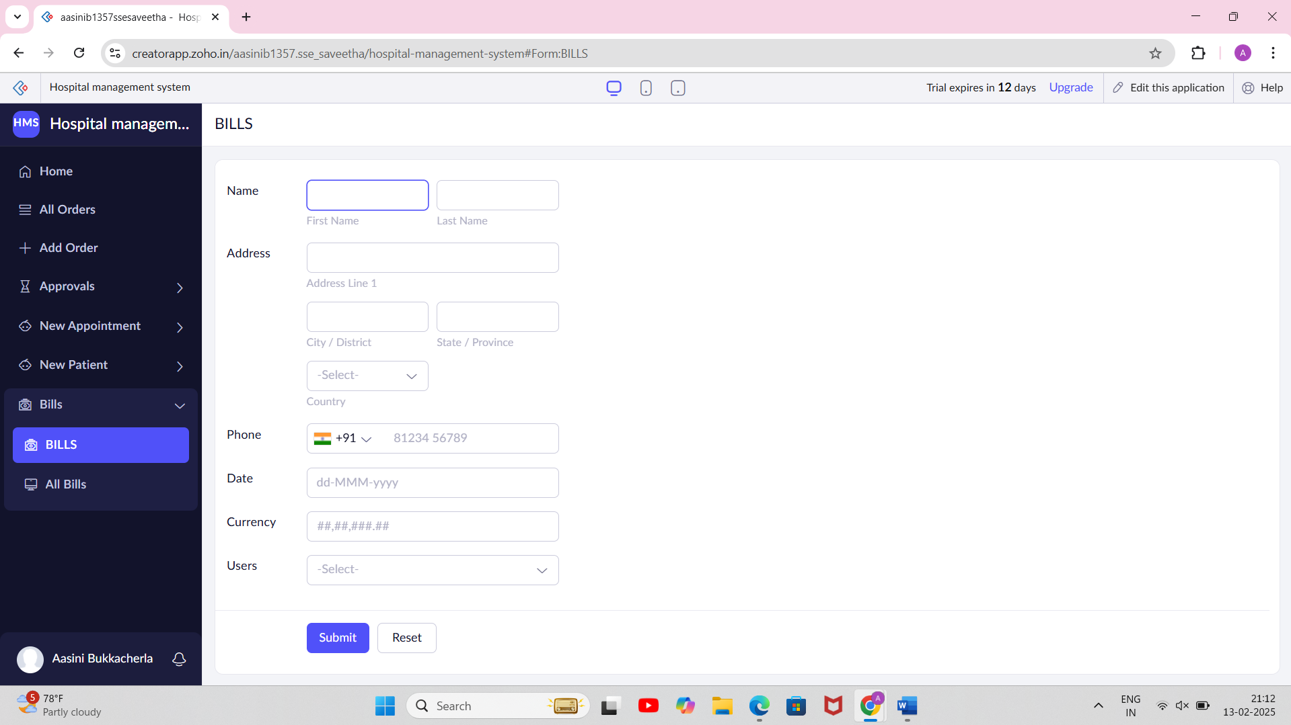

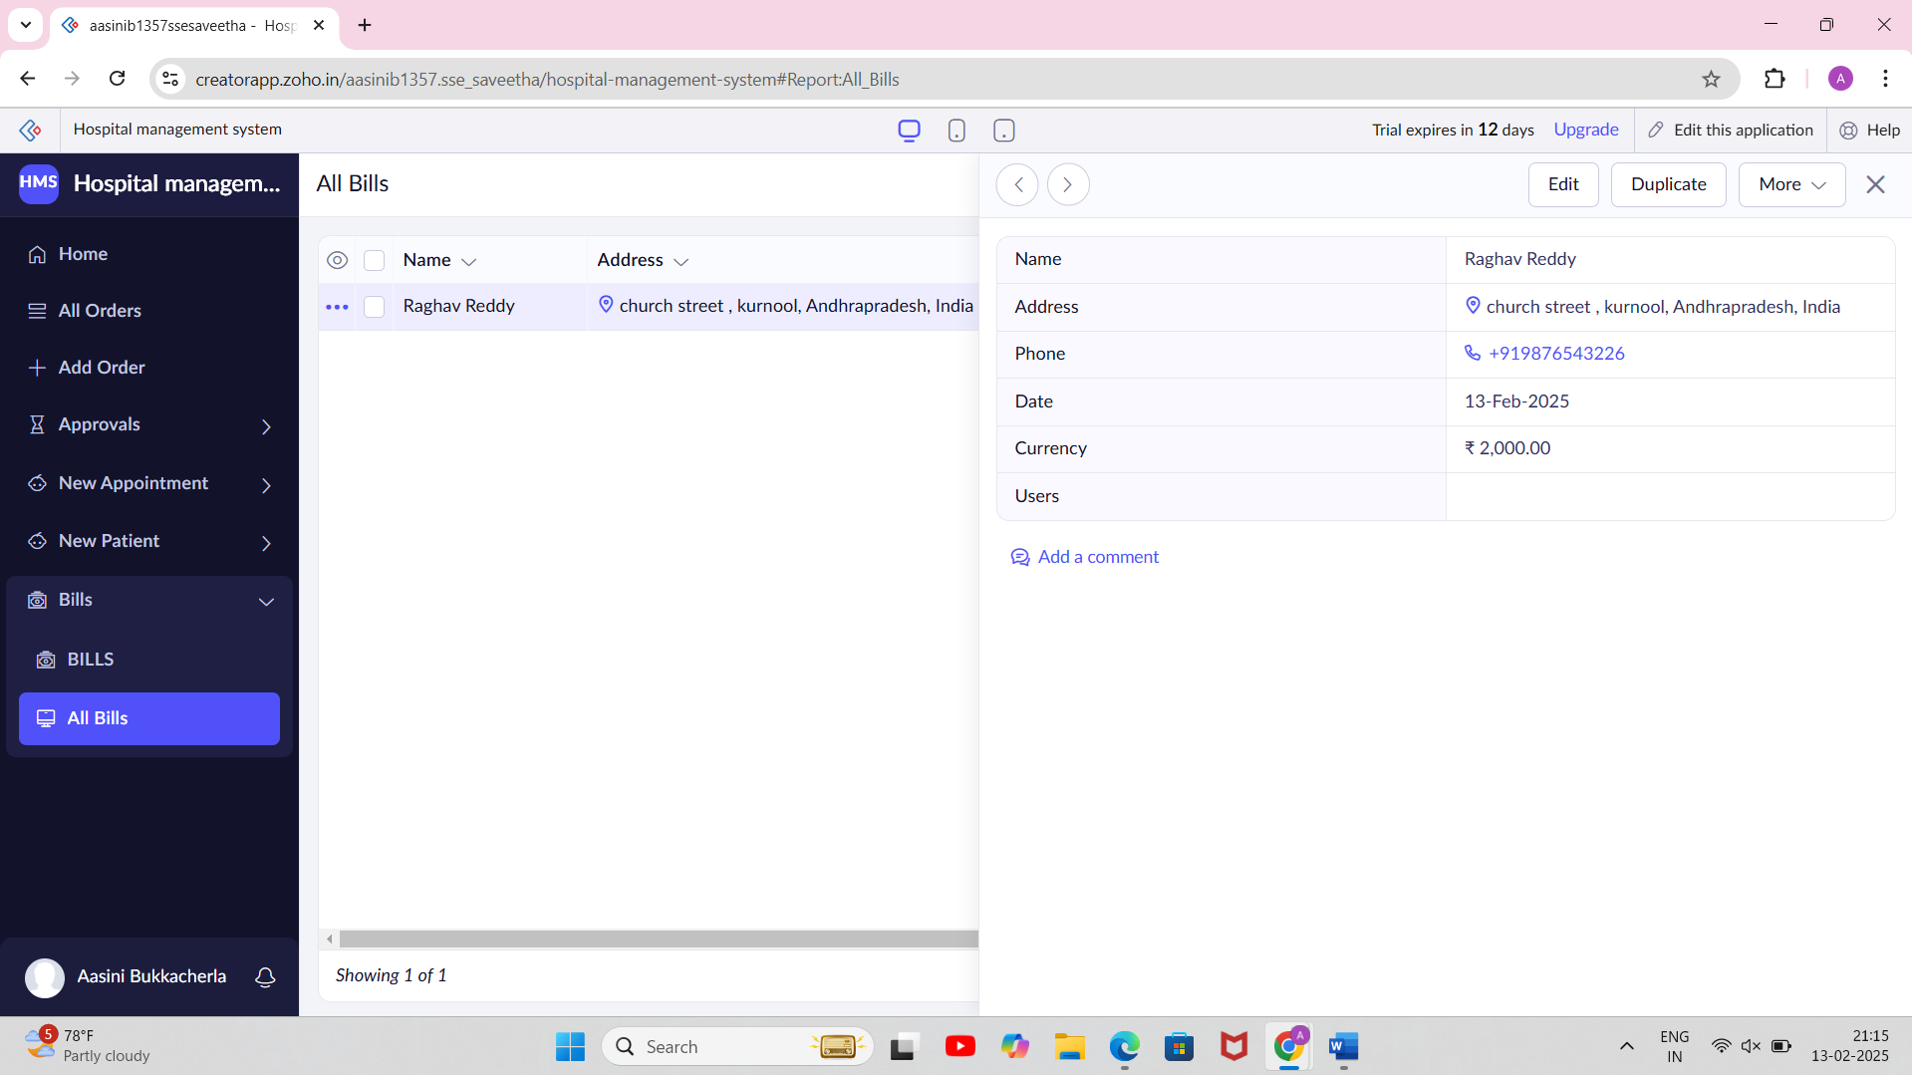

EXP NO 2:

CREATE A SIMPLE CLOUD SOFTWARE APPLICATION FOR FLIGHT RESERVATION SYSTEM USING ANY CLOUD SERVICE PROVIDER TO DEMONSTRATE SAAS.

AIM:

To create a simple cloud software application for flight reservation system using any cloud service provider to demonstrate saas.

PROCEDURE:

STEP1: GO TO ZOHO.COM.

STEP 2: LOG INTO THE ZOHO.COM.

STEP 3: SELECT ONE APPLICATION STEP.

STEP4: ENTER APPLICATION NAME AS FLIGHT RESERVATION SYSTEM.

STEP 5: CREATED NEW APPLICATION FLIGHT RESERVATION SYSTEM.

STEP 6: SELECT ONE FORM

STEP 7: THE SOFTWARE HAS BEEN CREATED.

SEAT BOOKING FORM:

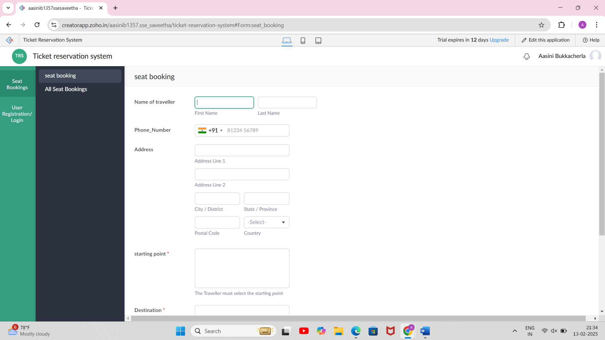

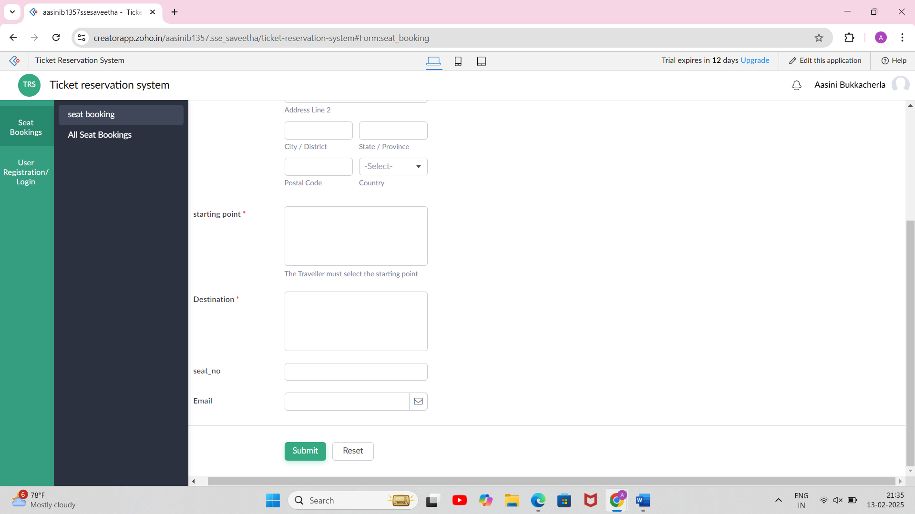

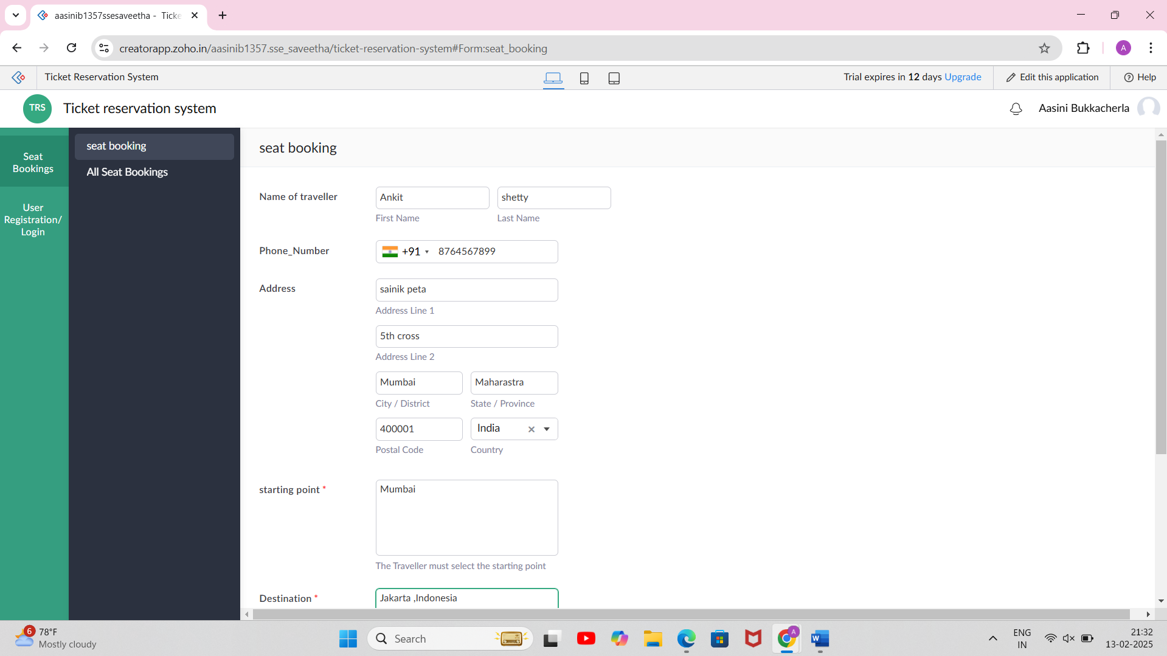

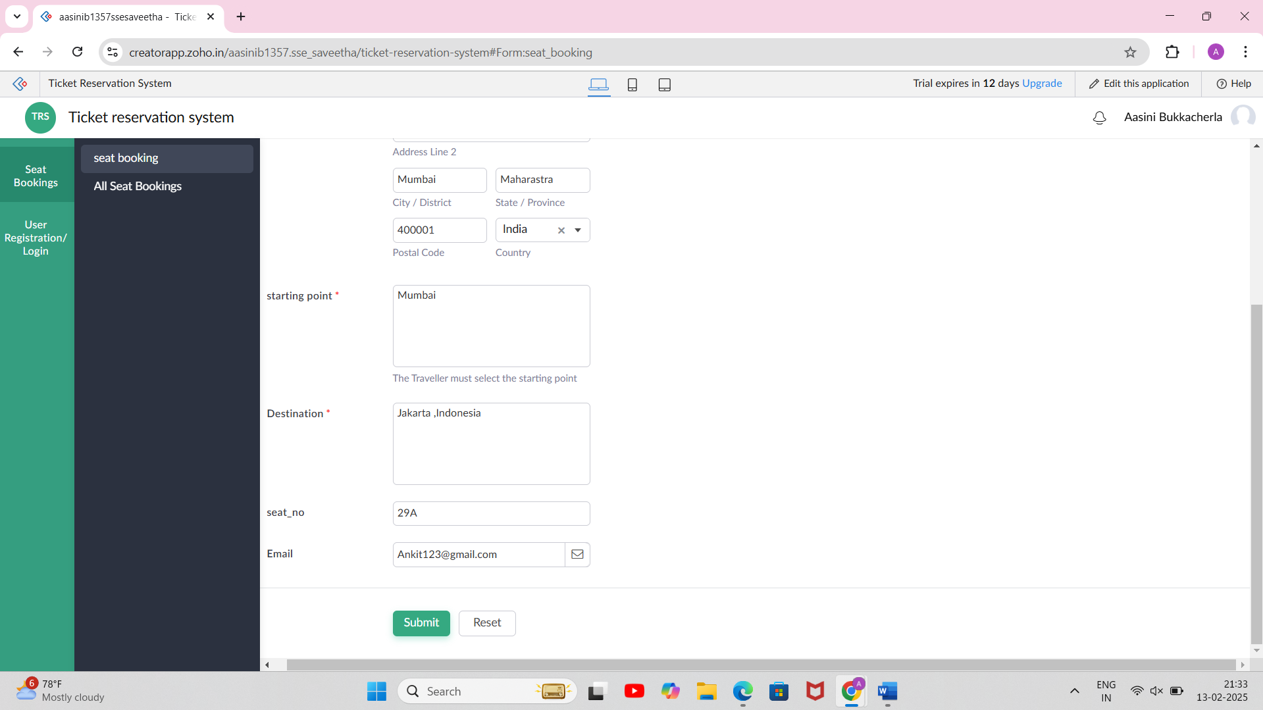

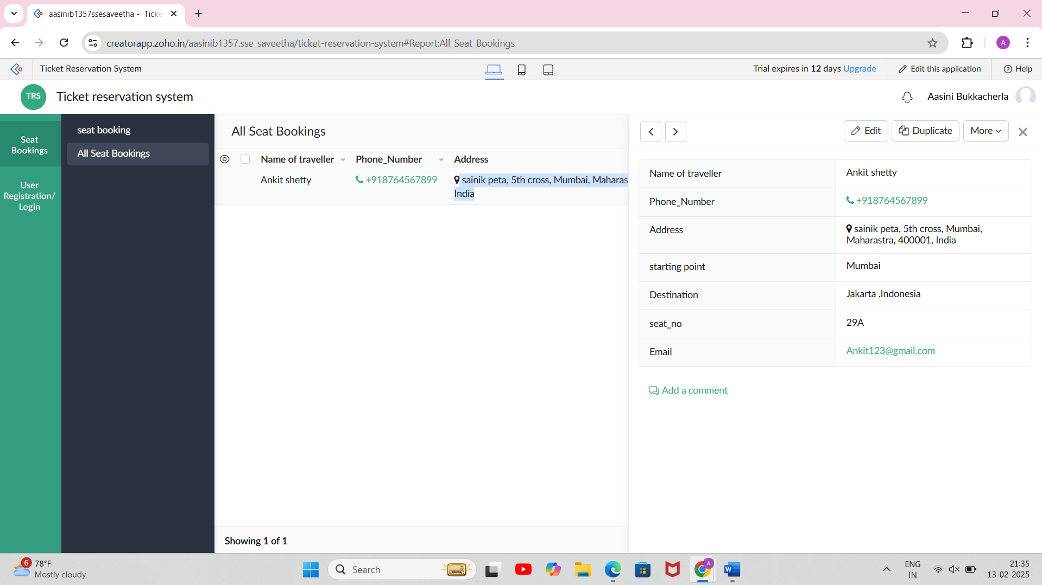

USER REGISTRATION/LOGIN FORM:

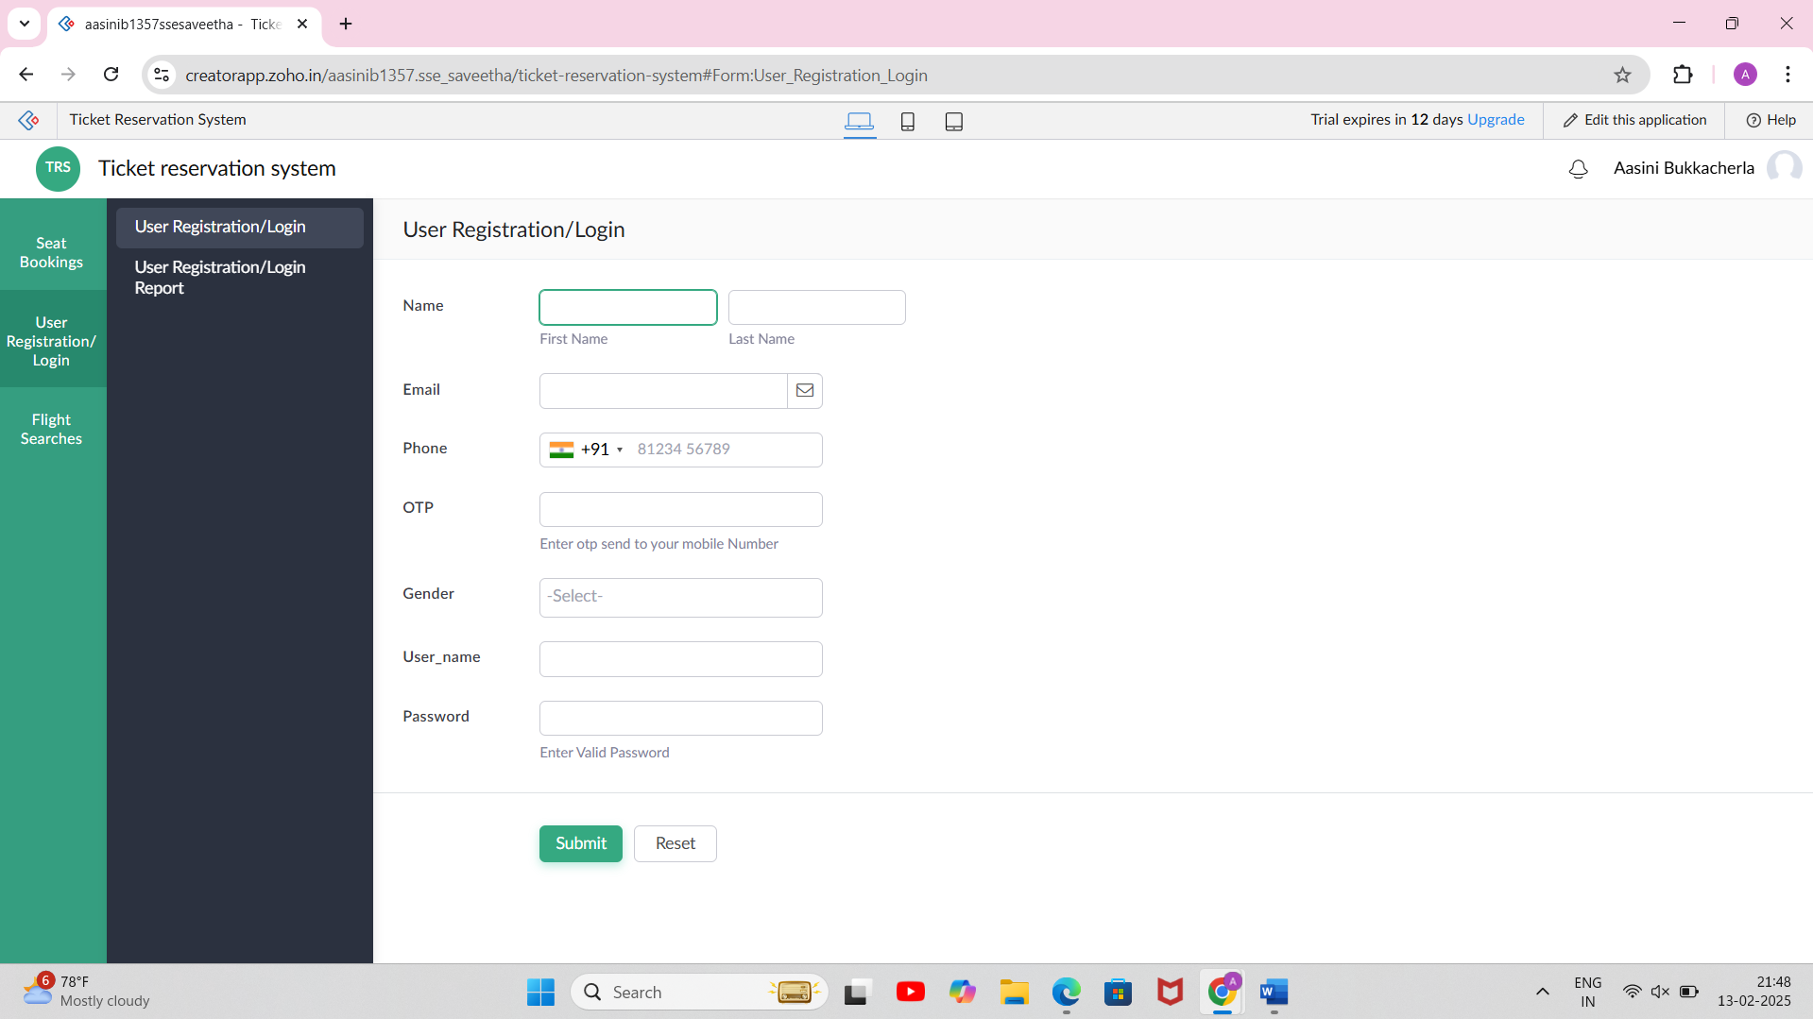

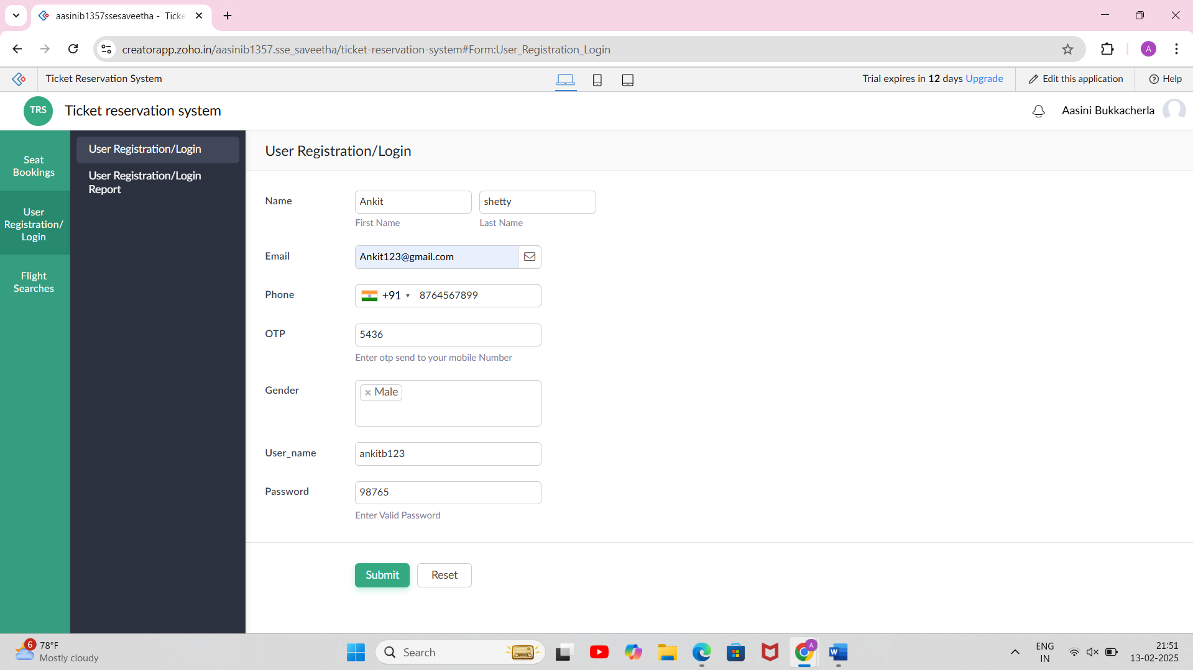

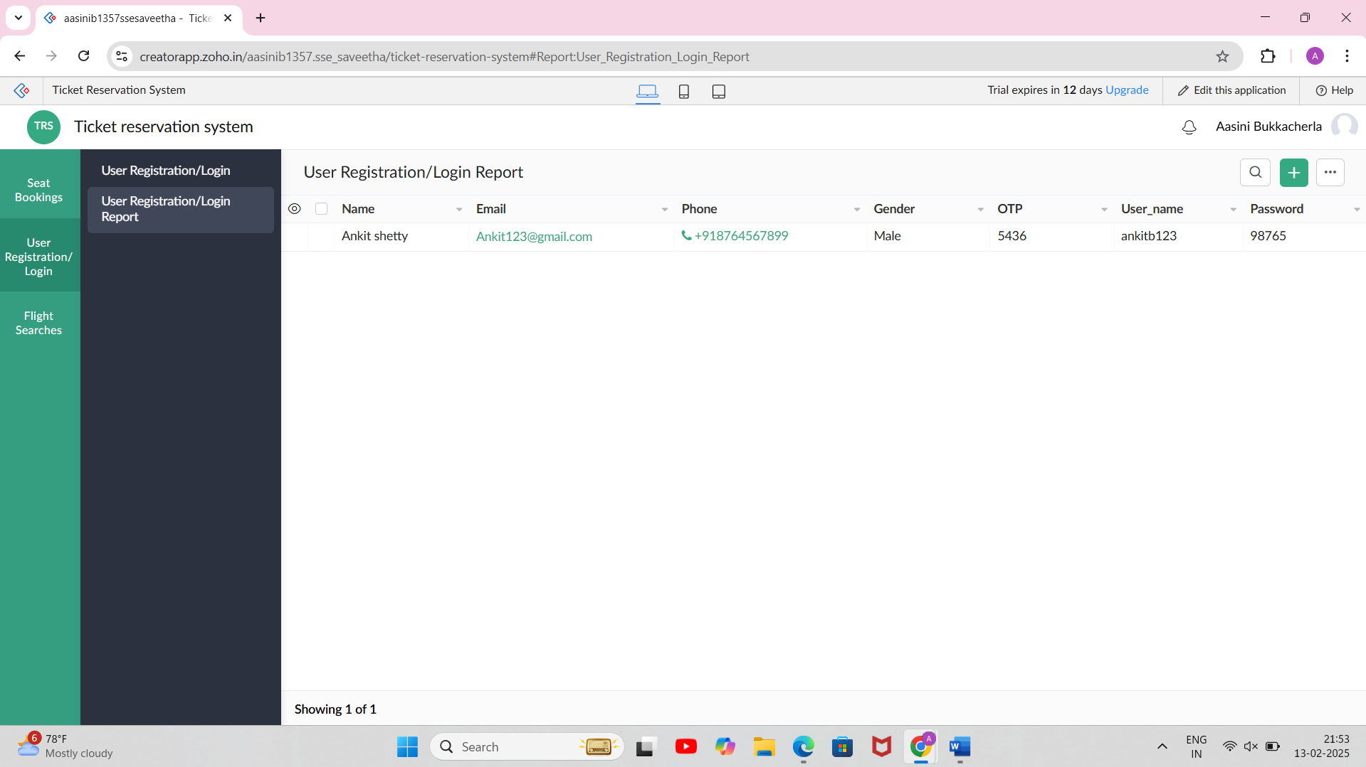

FLIGHT SEARCH FORM:

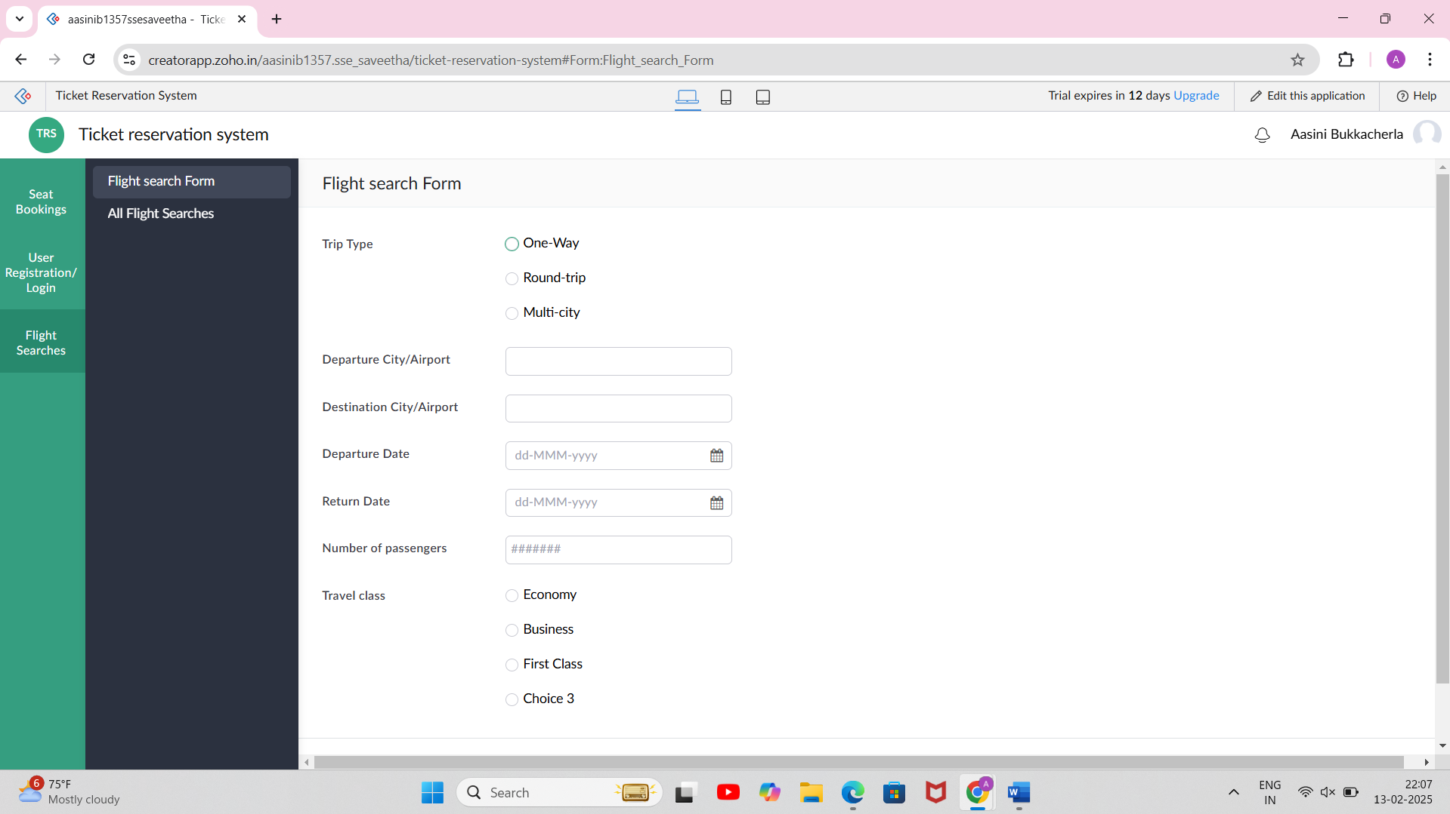

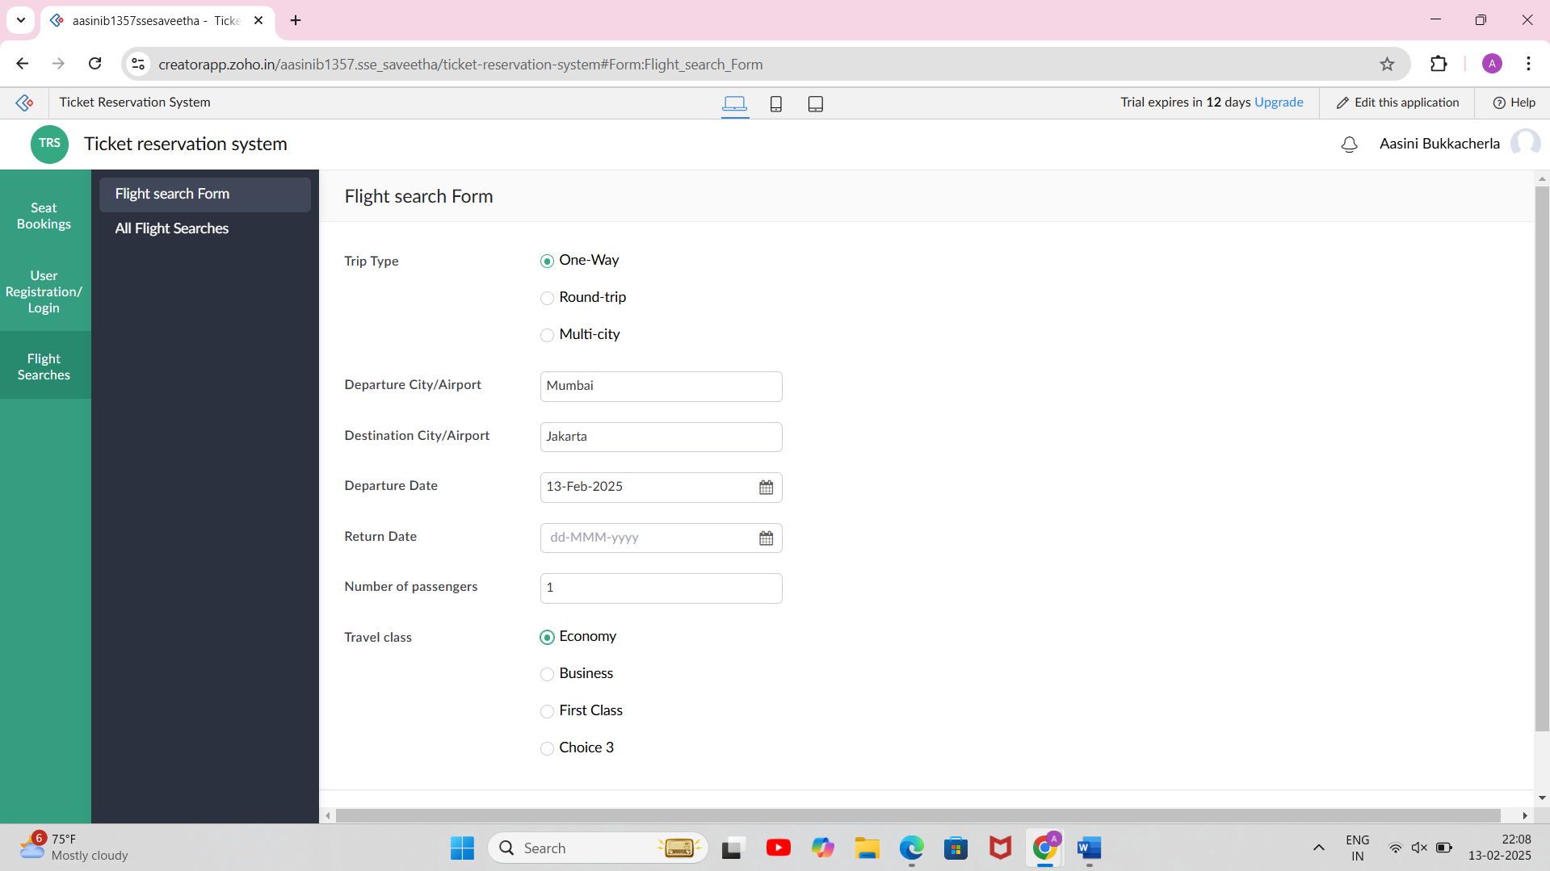

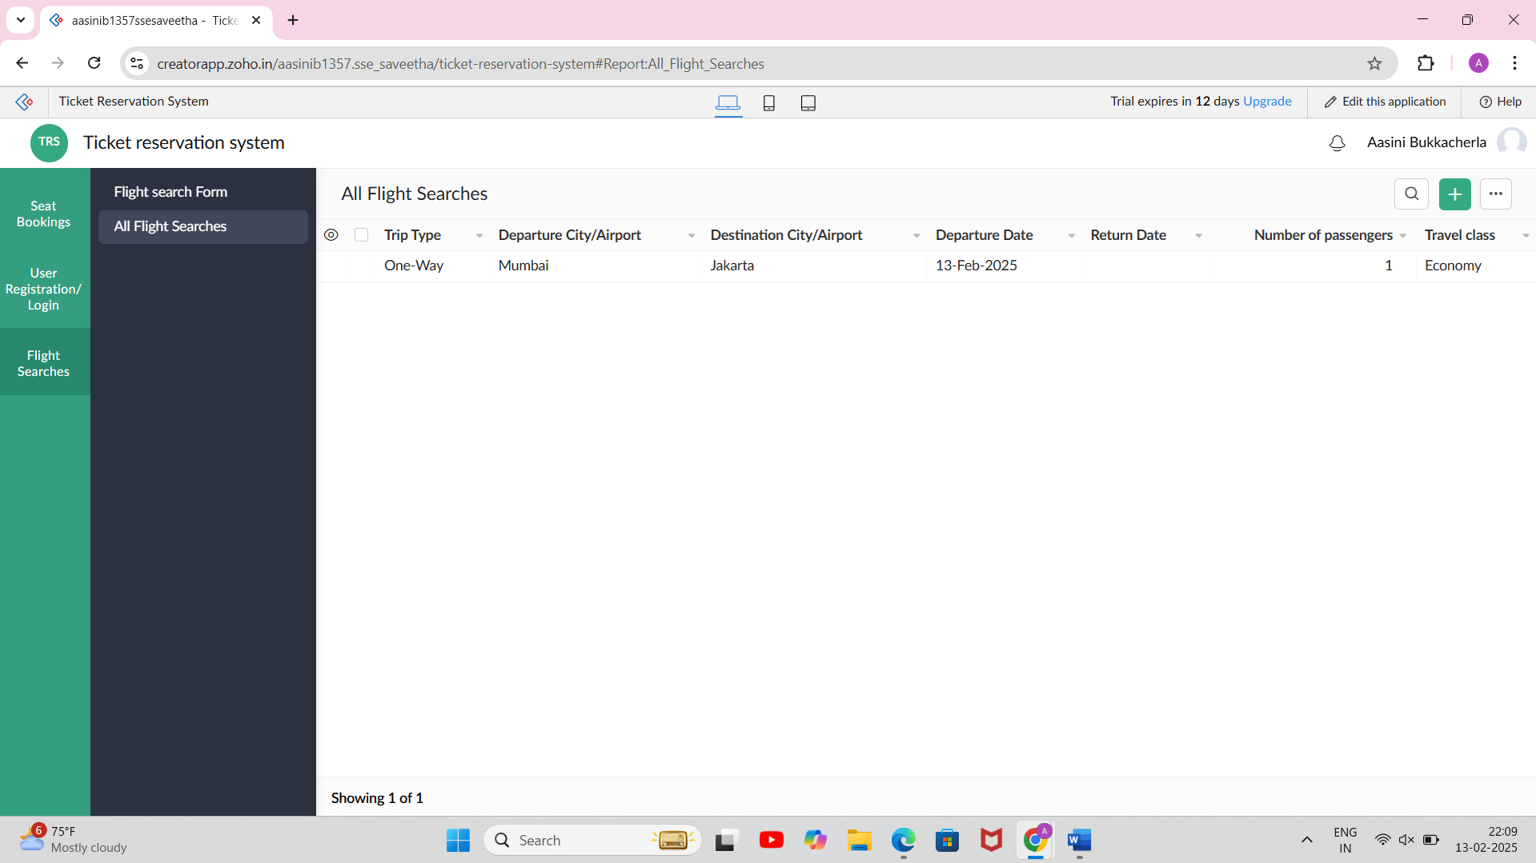

EXP NO 3:

CREATE A SIMPLE CLOUD SOFTWARE APPLICATION FOR PROPERTY BUYING & RENTAL PROCESS (IN CHENNAI CITY) USING ANY CLOUD SERVICE PROVIDER TO DEMONSTRATE SAAS.

AIM:

To Create a simple cloud software application for Property Buying & Rental process (In Chennai city) using any Cloud Service Provider to demonstrate SaaS.

PROCEDURE:

STEP1: GO TO ZOHO.COM.

STEP 2: LOG INTO THE ZOHO.COM.

STEP 3: SELECT ONE APPLICATION STEP.

STEP4: ENTER APPLICATION NAME AS PROPERTY BUYING & RENTAL.

STEP 5: CREATED NEW APPLICATION AS PROPERTY BUYING & RENTAL.

STEP 6: SELECT ONE FORM

STEP 7: THE SOFTWARE HAS BEEN CREATED.

PROPERTY FORM:

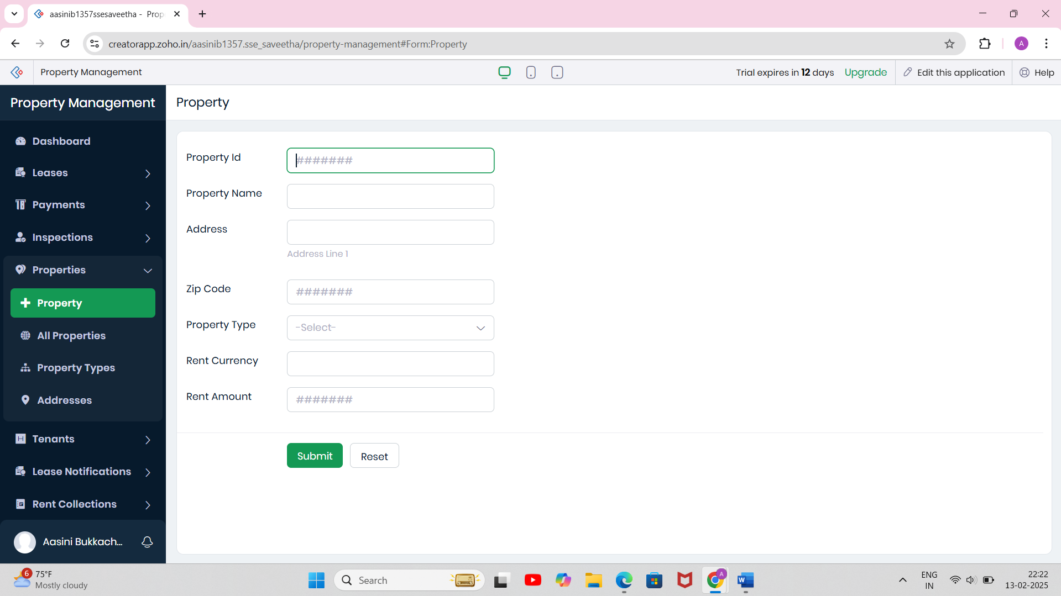

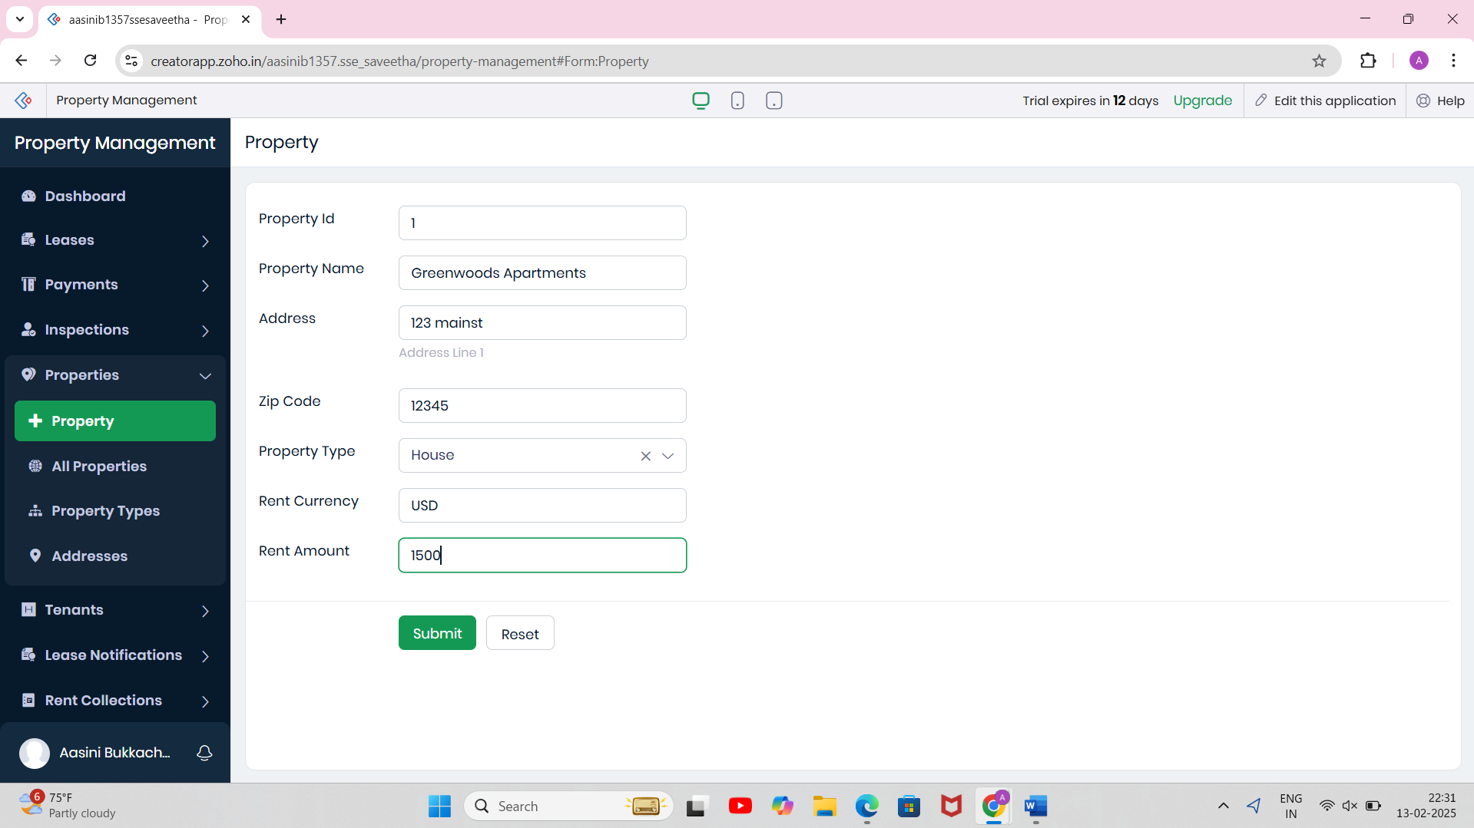

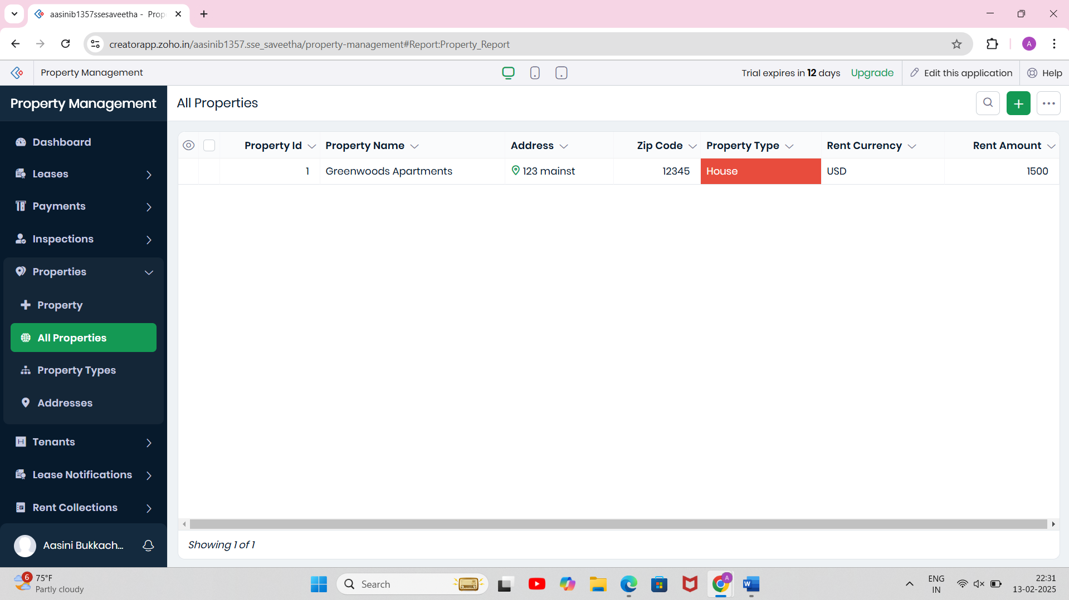

TENANT INFORMATION FORM:

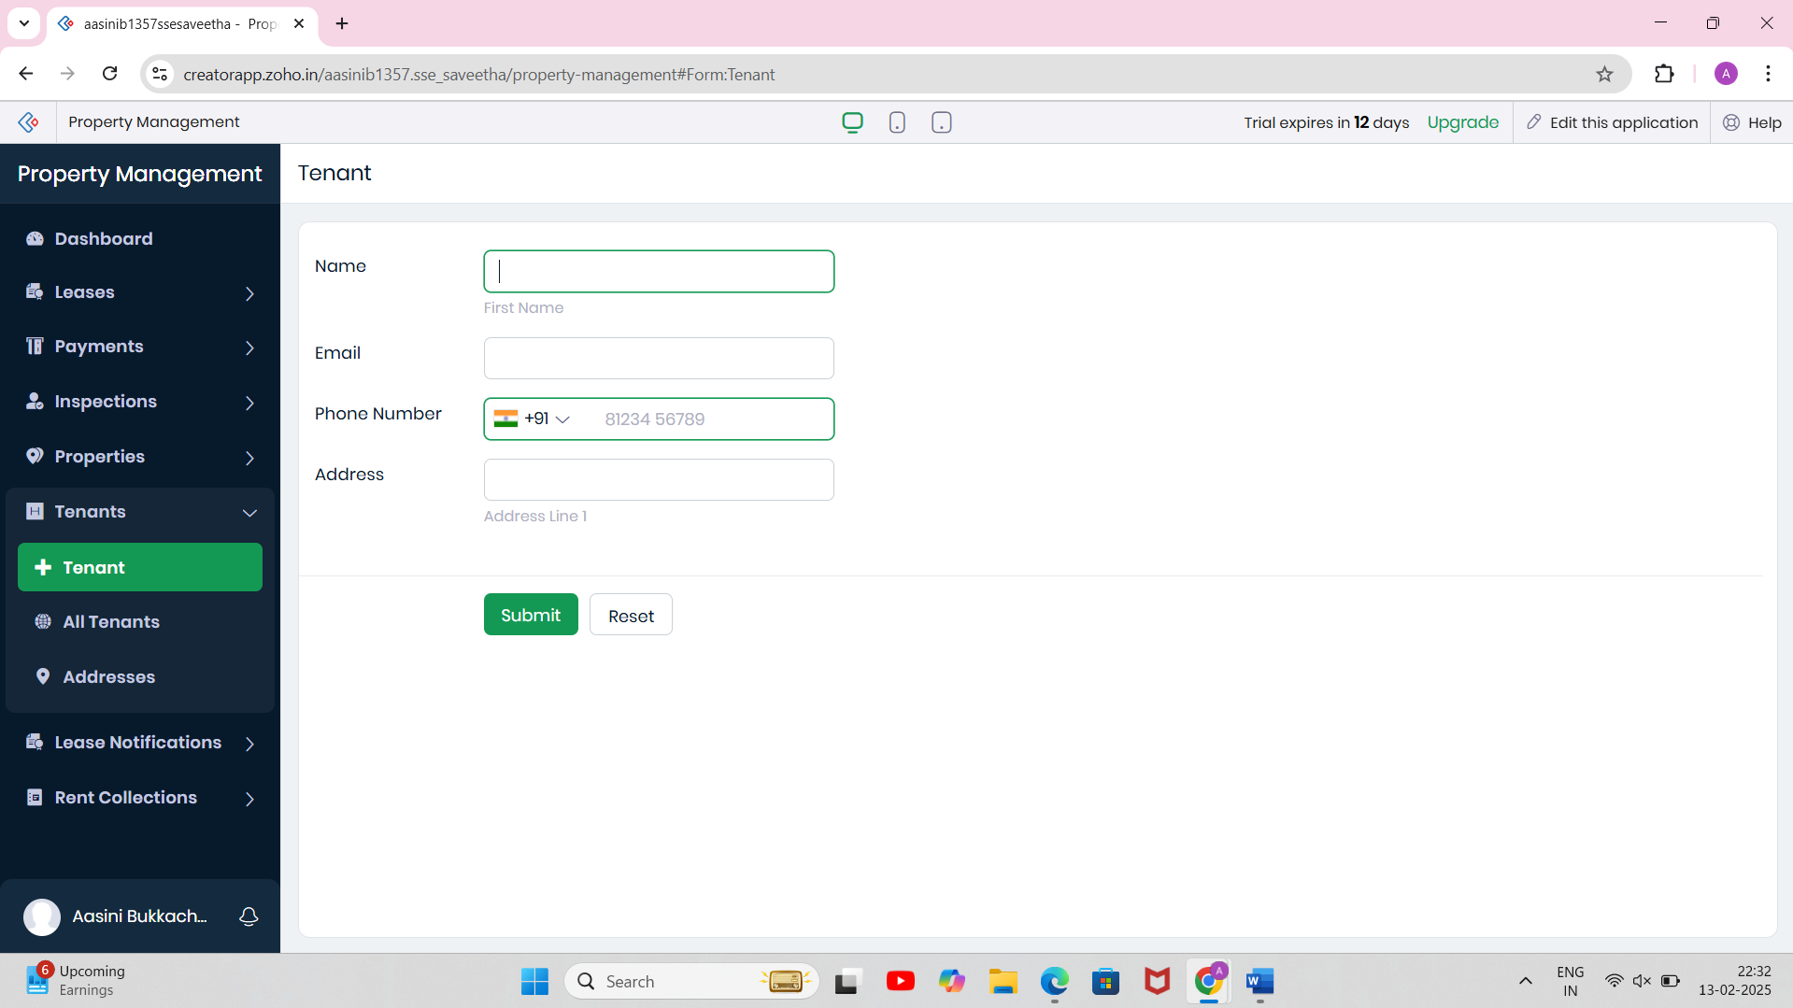

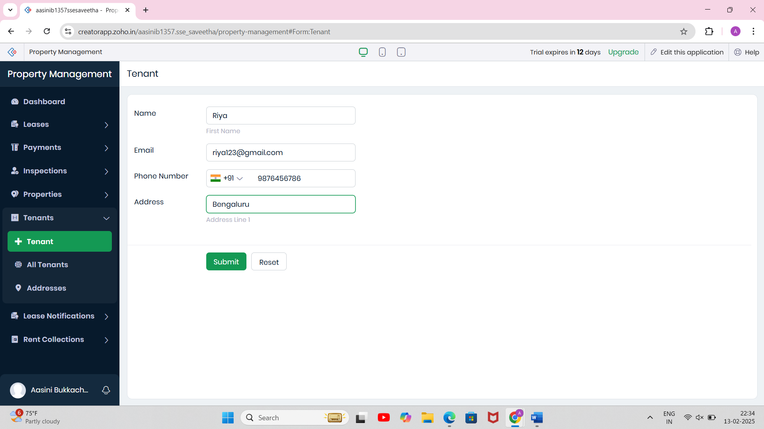

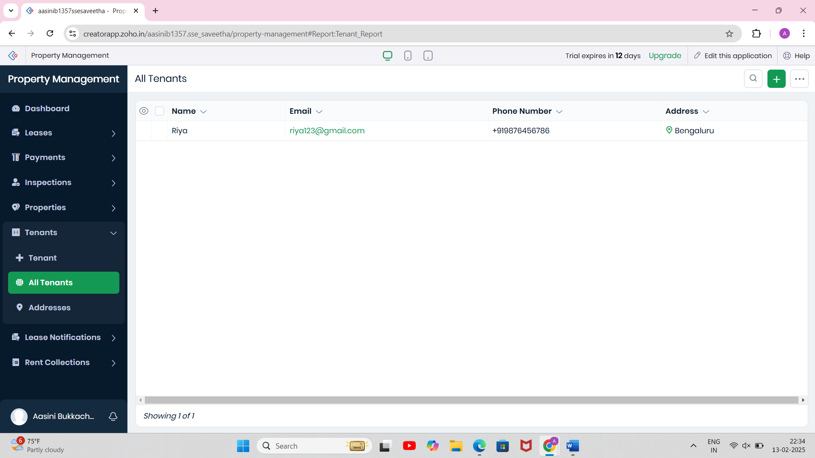

RENT COLLECTION FORM:

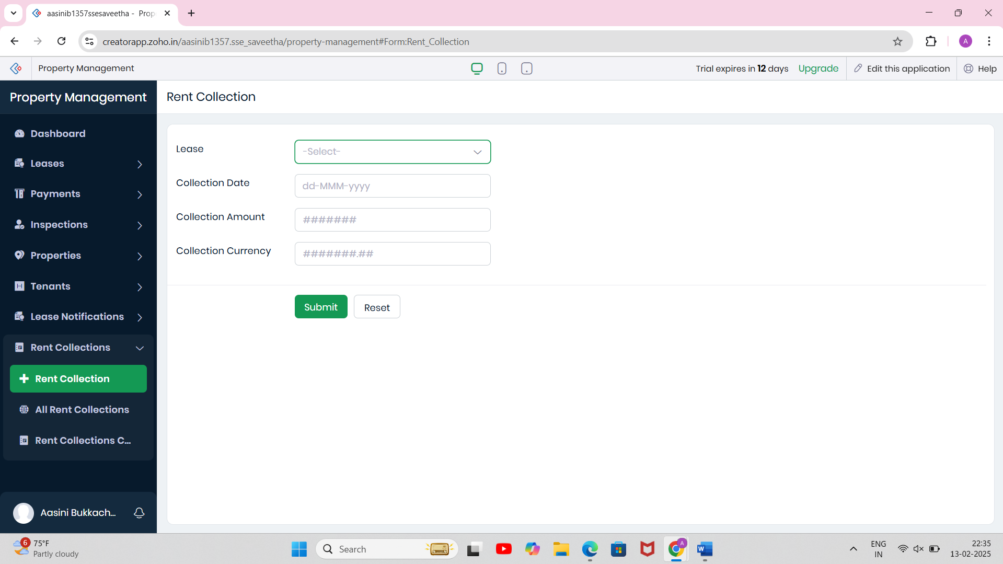

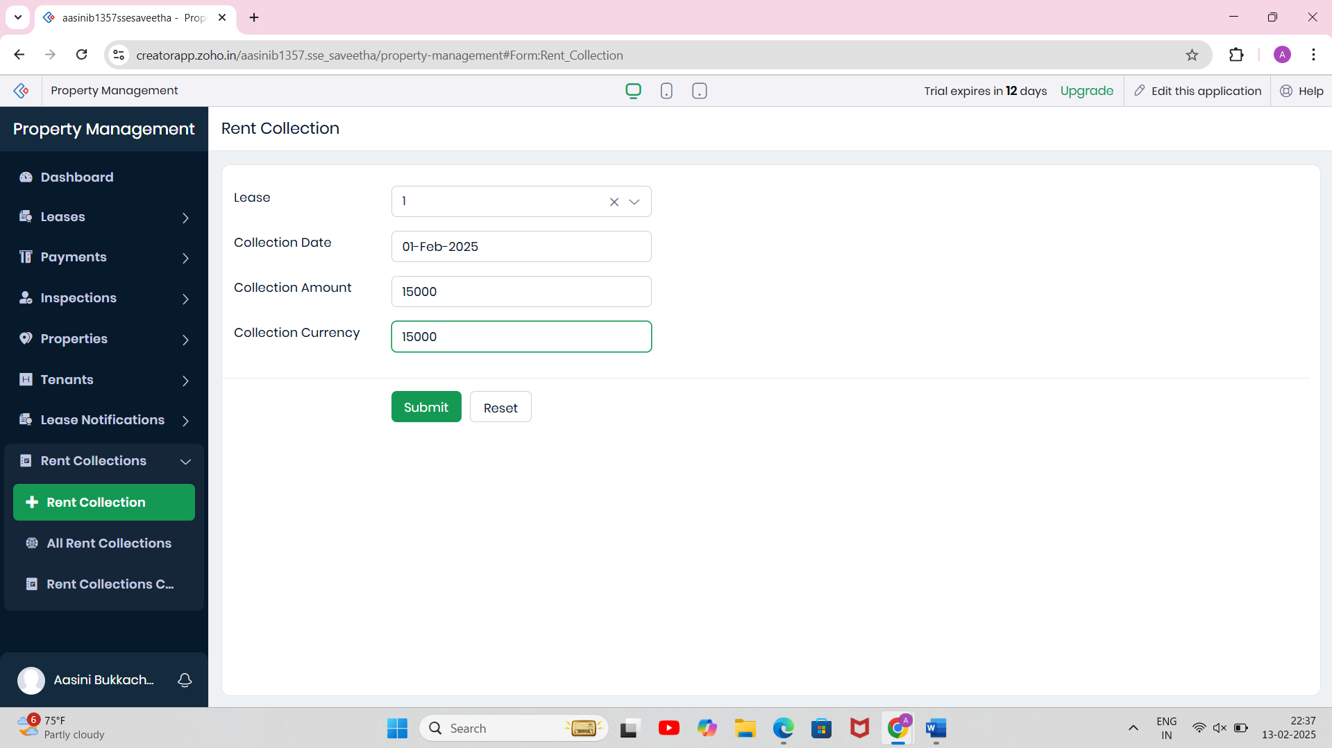

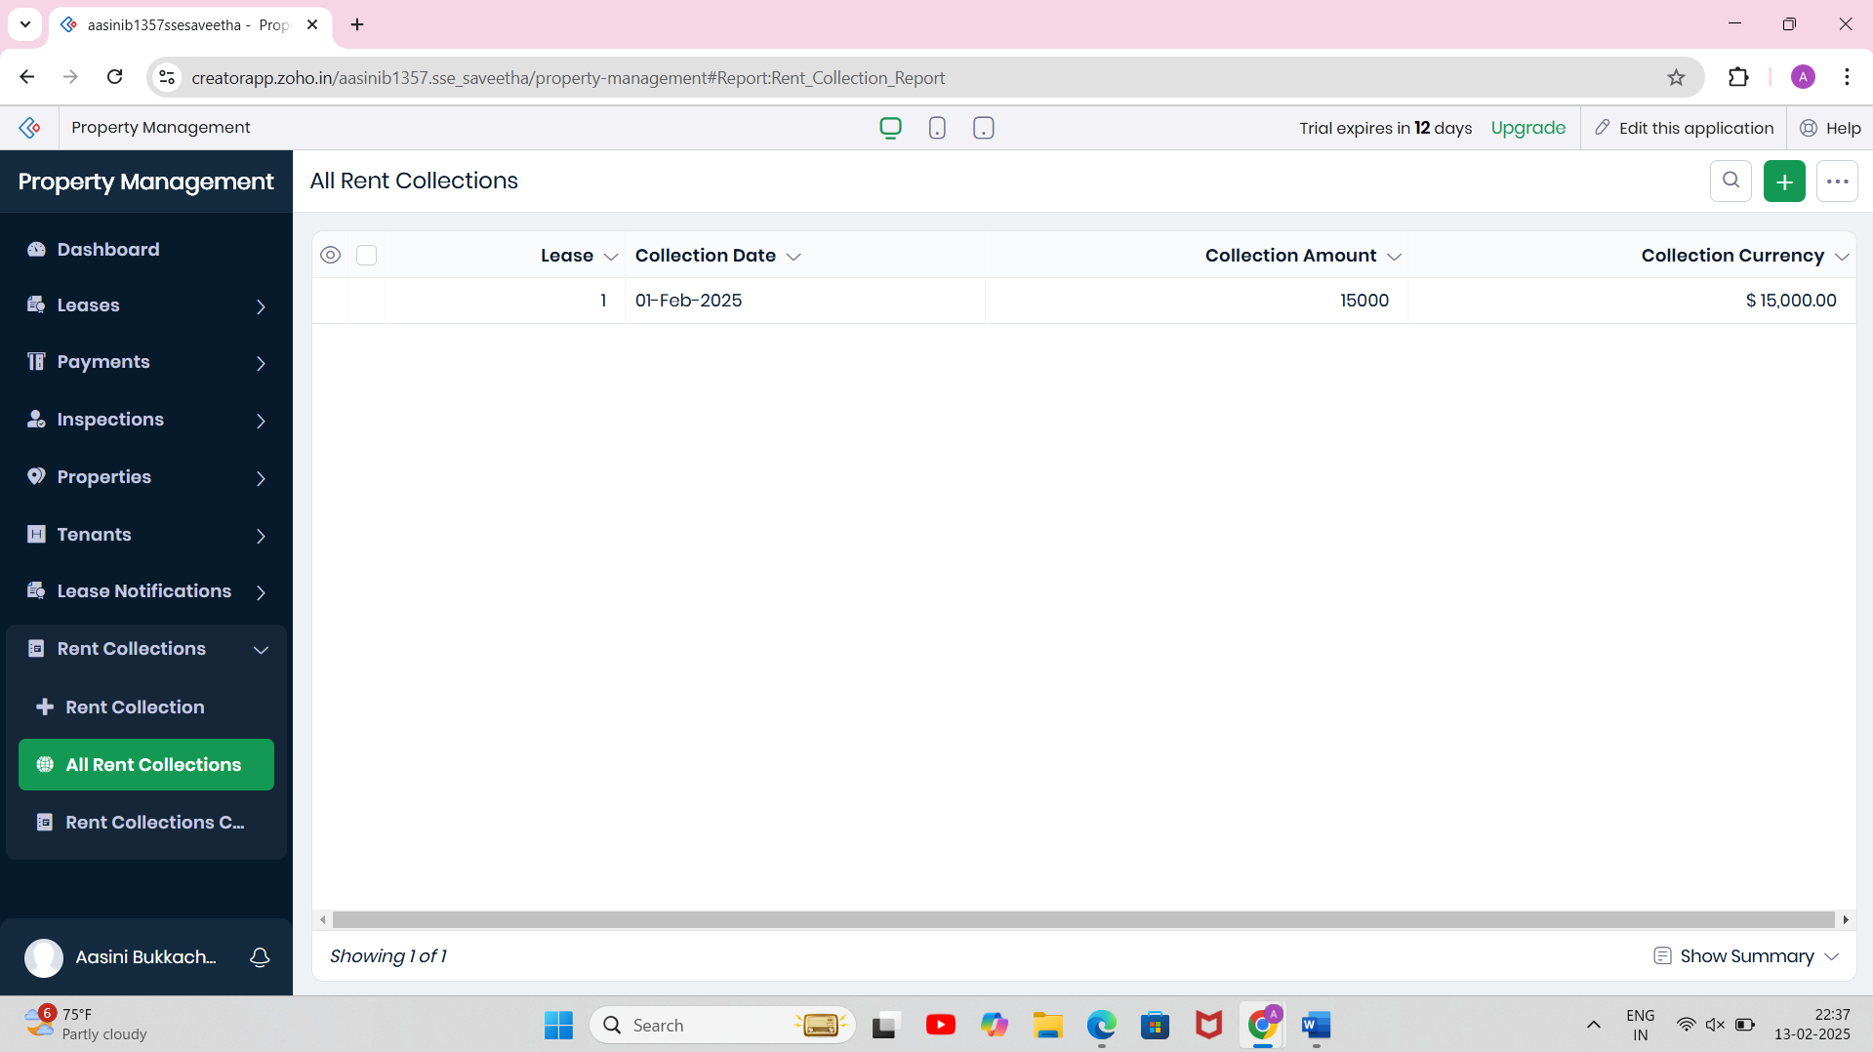

EXP NO 4:

CREATE A SIMPLE CLOUD SOFTWARE APPLICATION FOR CAR BOOKING RESERVATION SYSTEM USING ANY CLOUD SERVICE PROVIDER TO DEMONSTRATE SAAS.

AIM:

To Create a simple cloud software application for Car Booking Reservation System using any Cloud Service Provider to demonstrate SaaS.

PROCEDURE:

STEP1: GO TO ZOHO.COM.

STEP 2: LOG INTO THE ZOHO.COM.

STEP 3: SELECT ONE APPLICATION STEP.

STEP4: ENTER APPLICATION NAME AS CAR BOOKING RESERVATION SYSTEM.

STEP 5: CREATED NEW APPLICATION AS CAR BOOKING RESERVATION SYSTEM.

STEP 6: SELECT ONE FORM

STEP 7: THE SOFTWARE HAS BEEN CREATED.

DRIVER INFORMATION FORM:

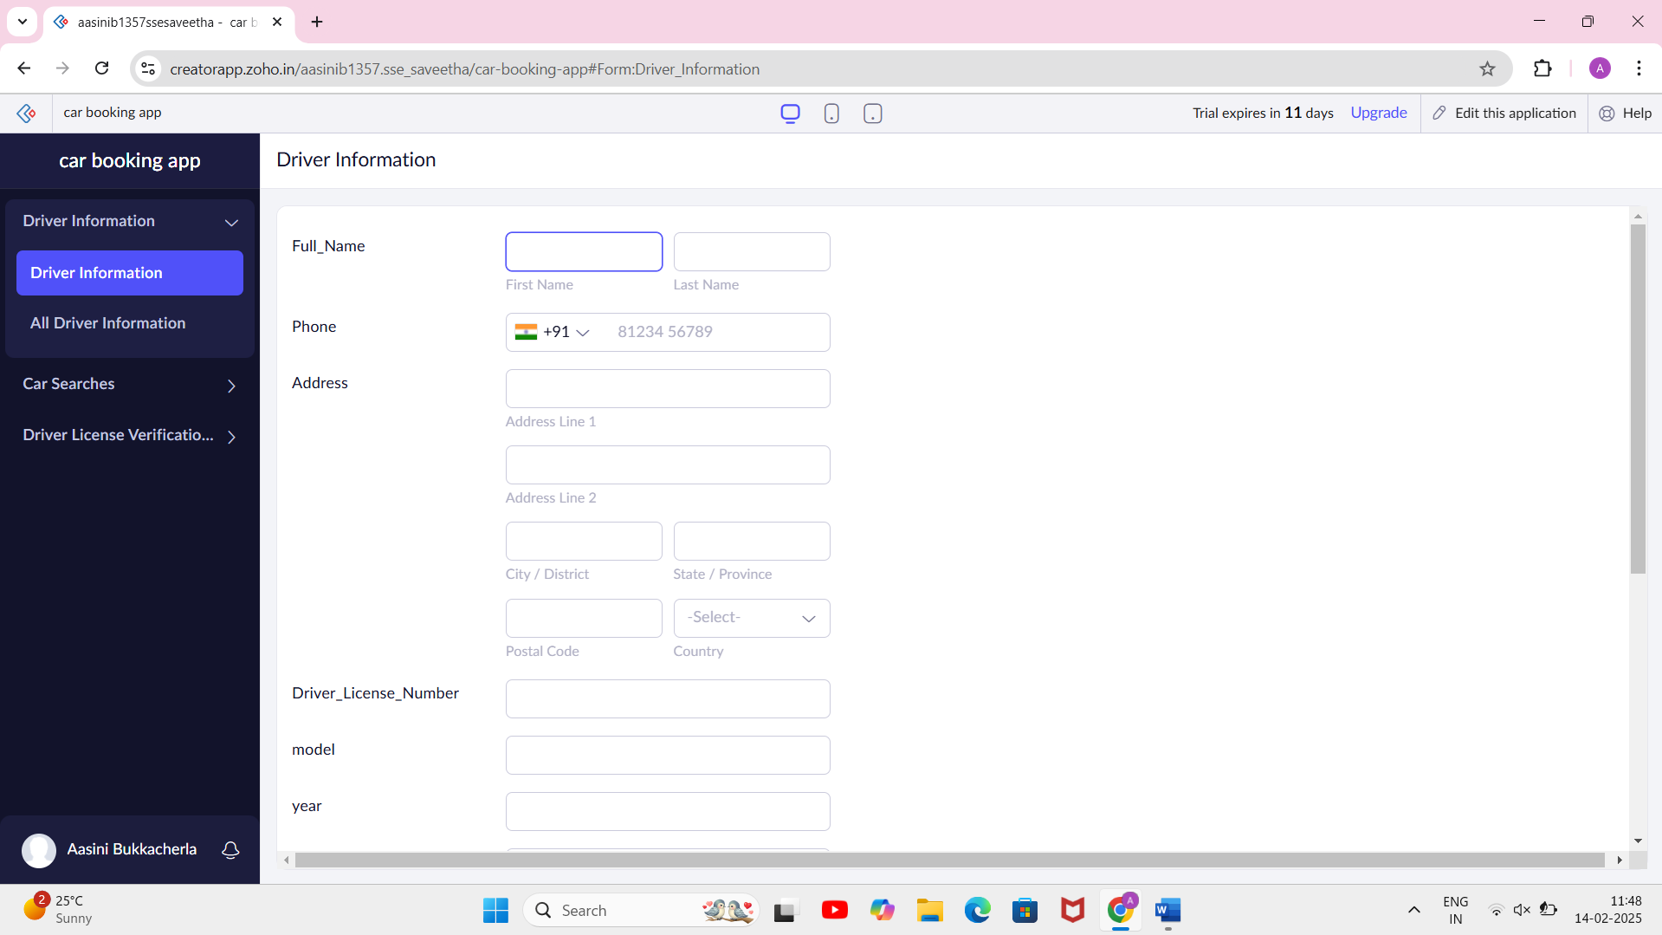

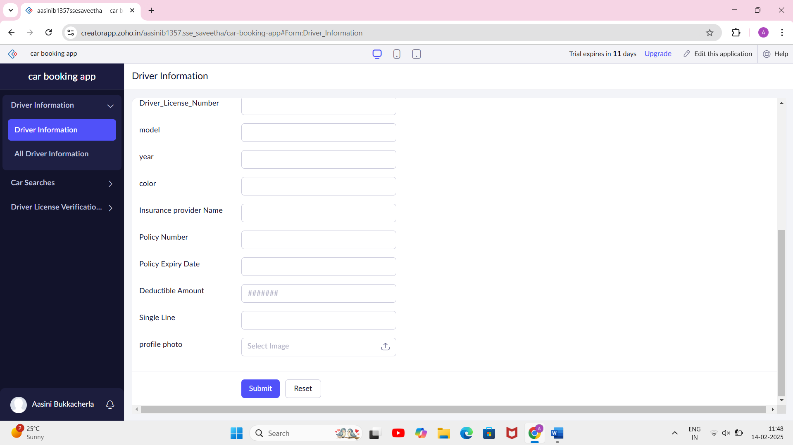

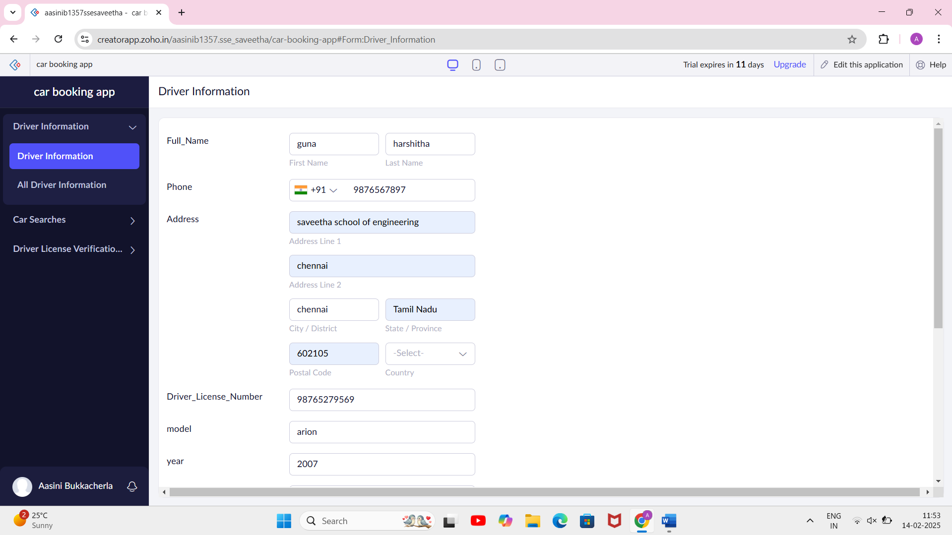

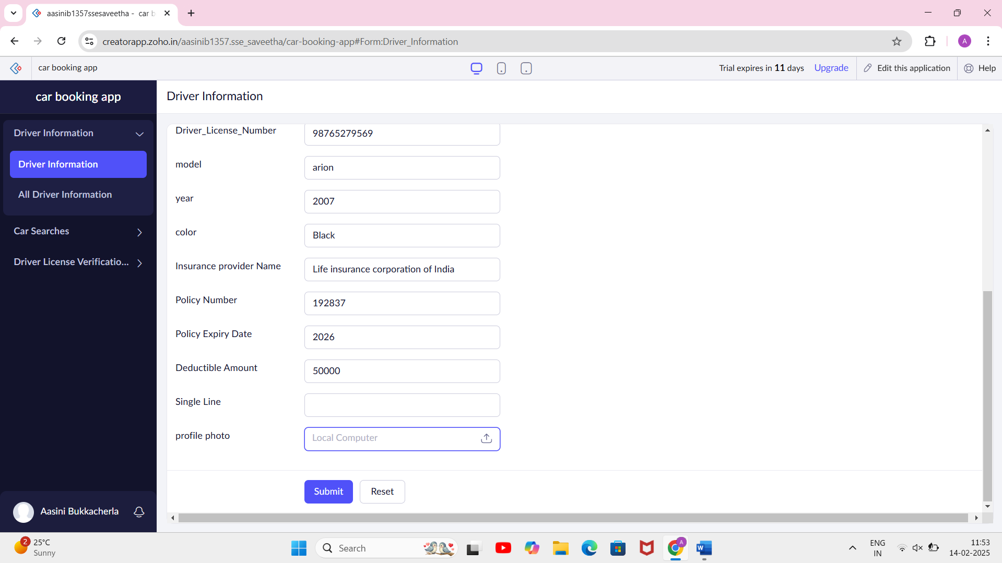

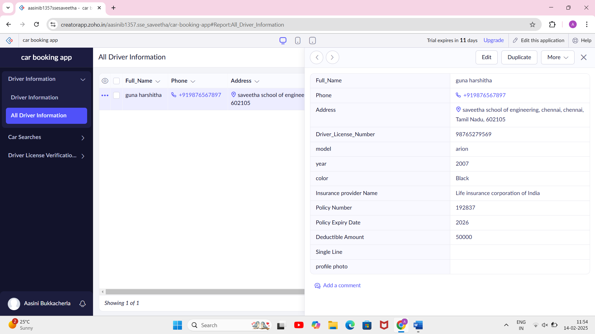

CAR SEARCHING FORM:

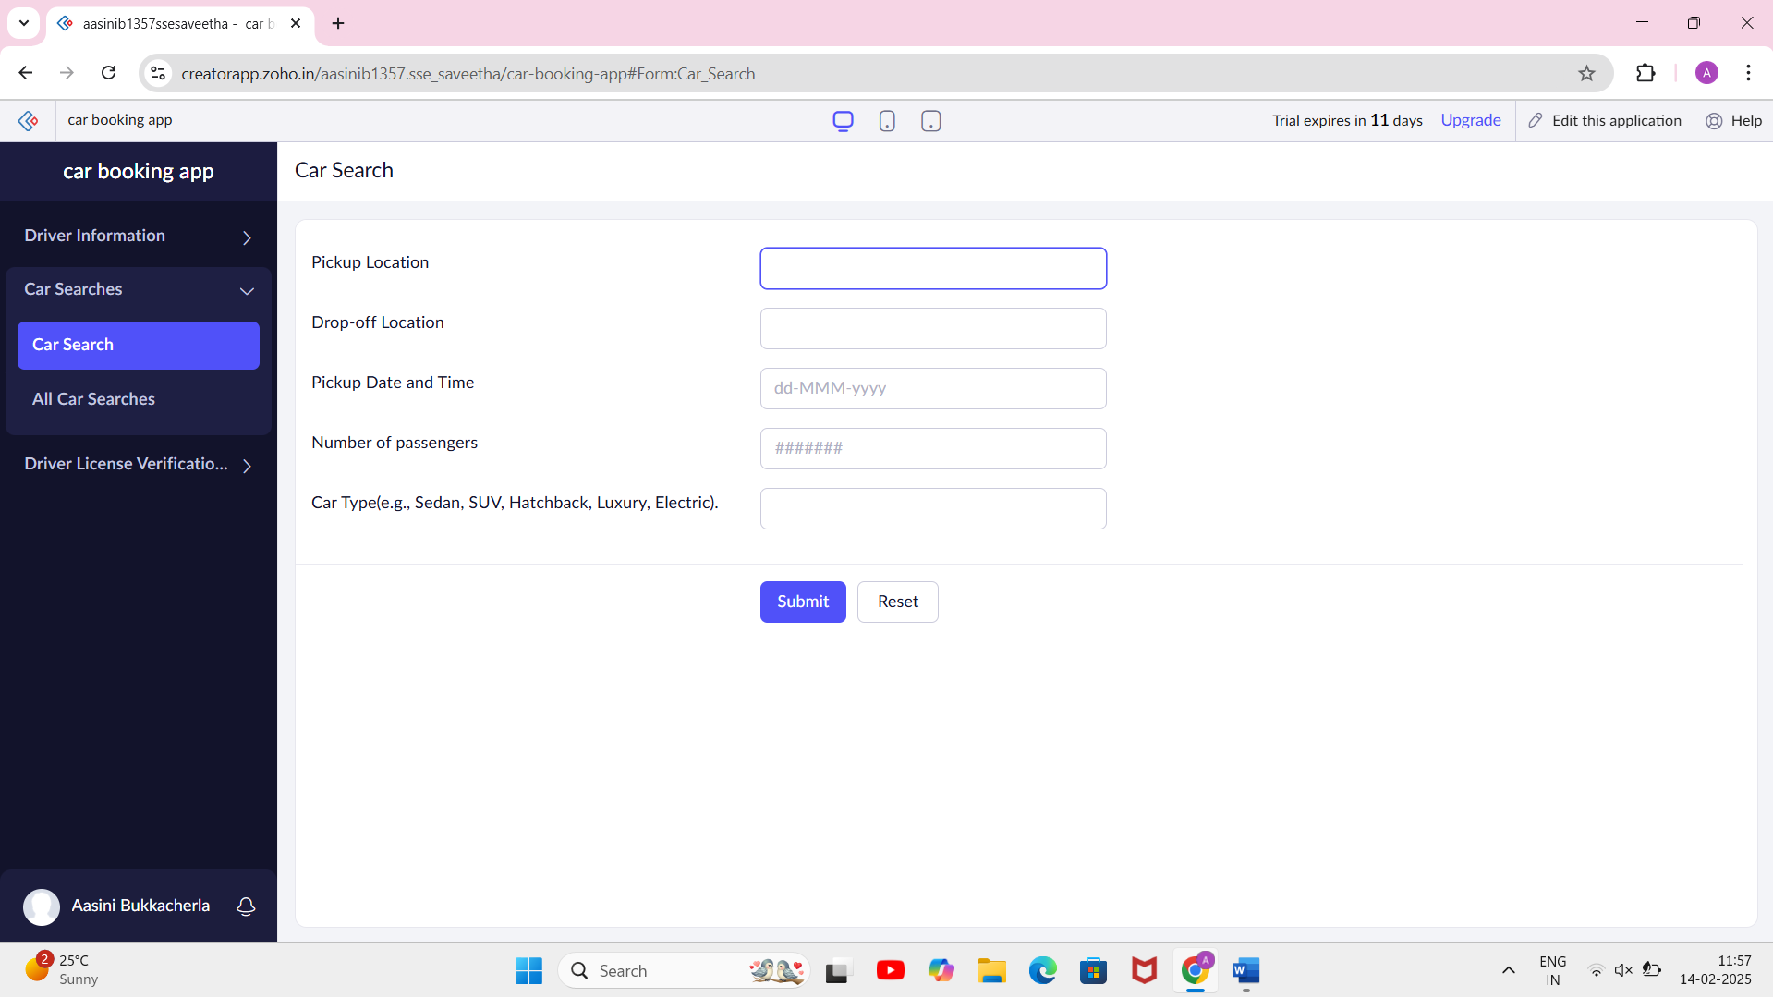

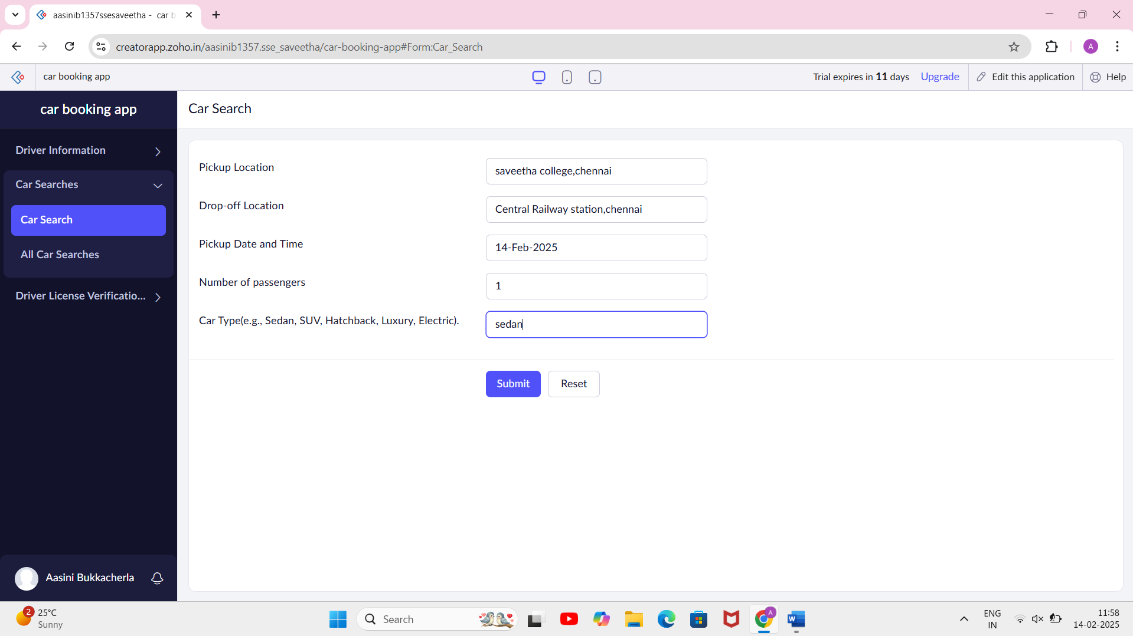

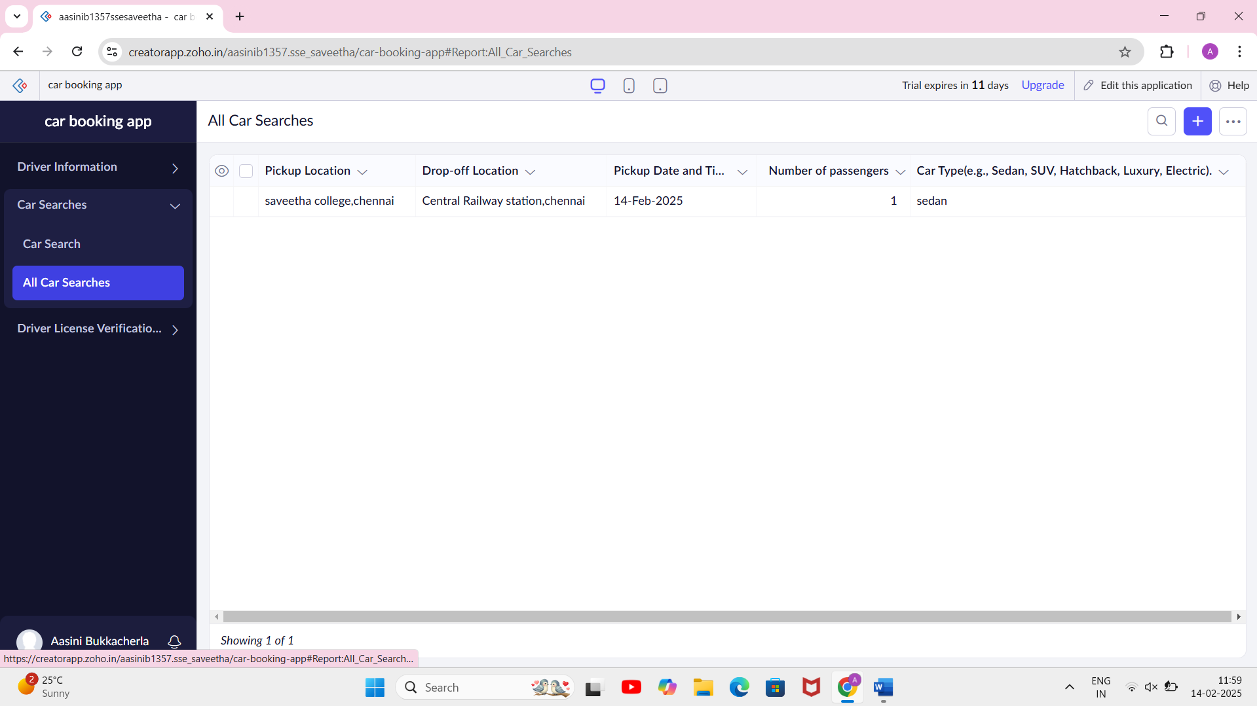

DRIVER LICENSE VERIFICATION FORM:

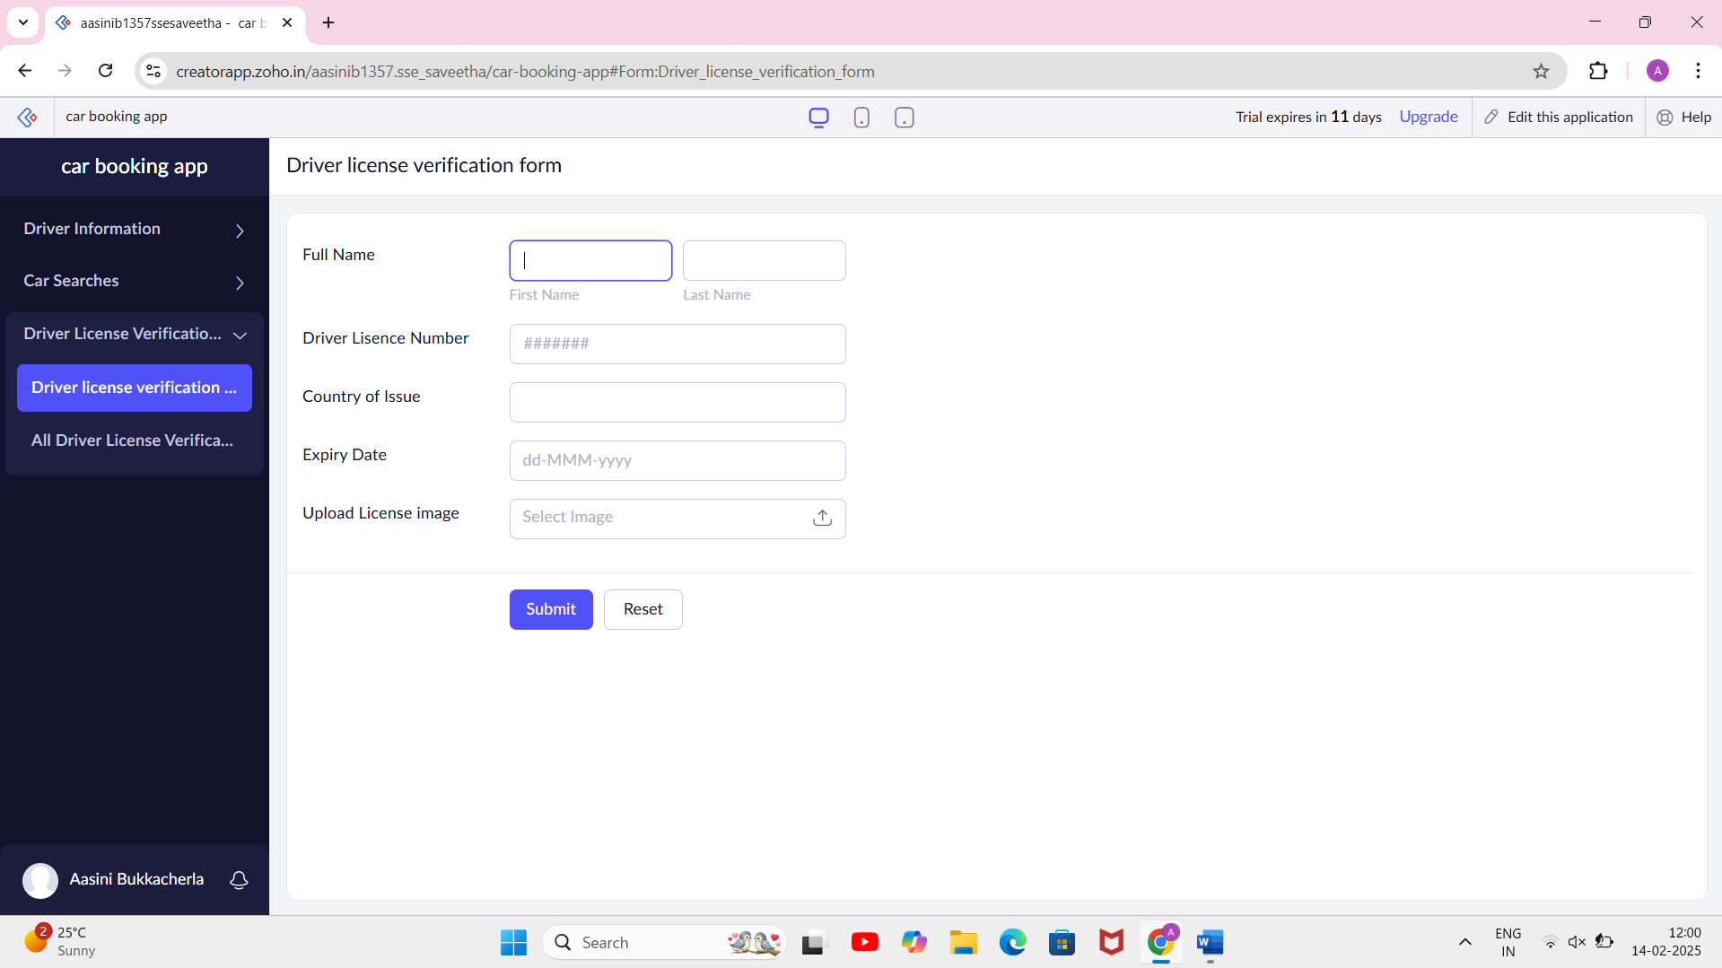

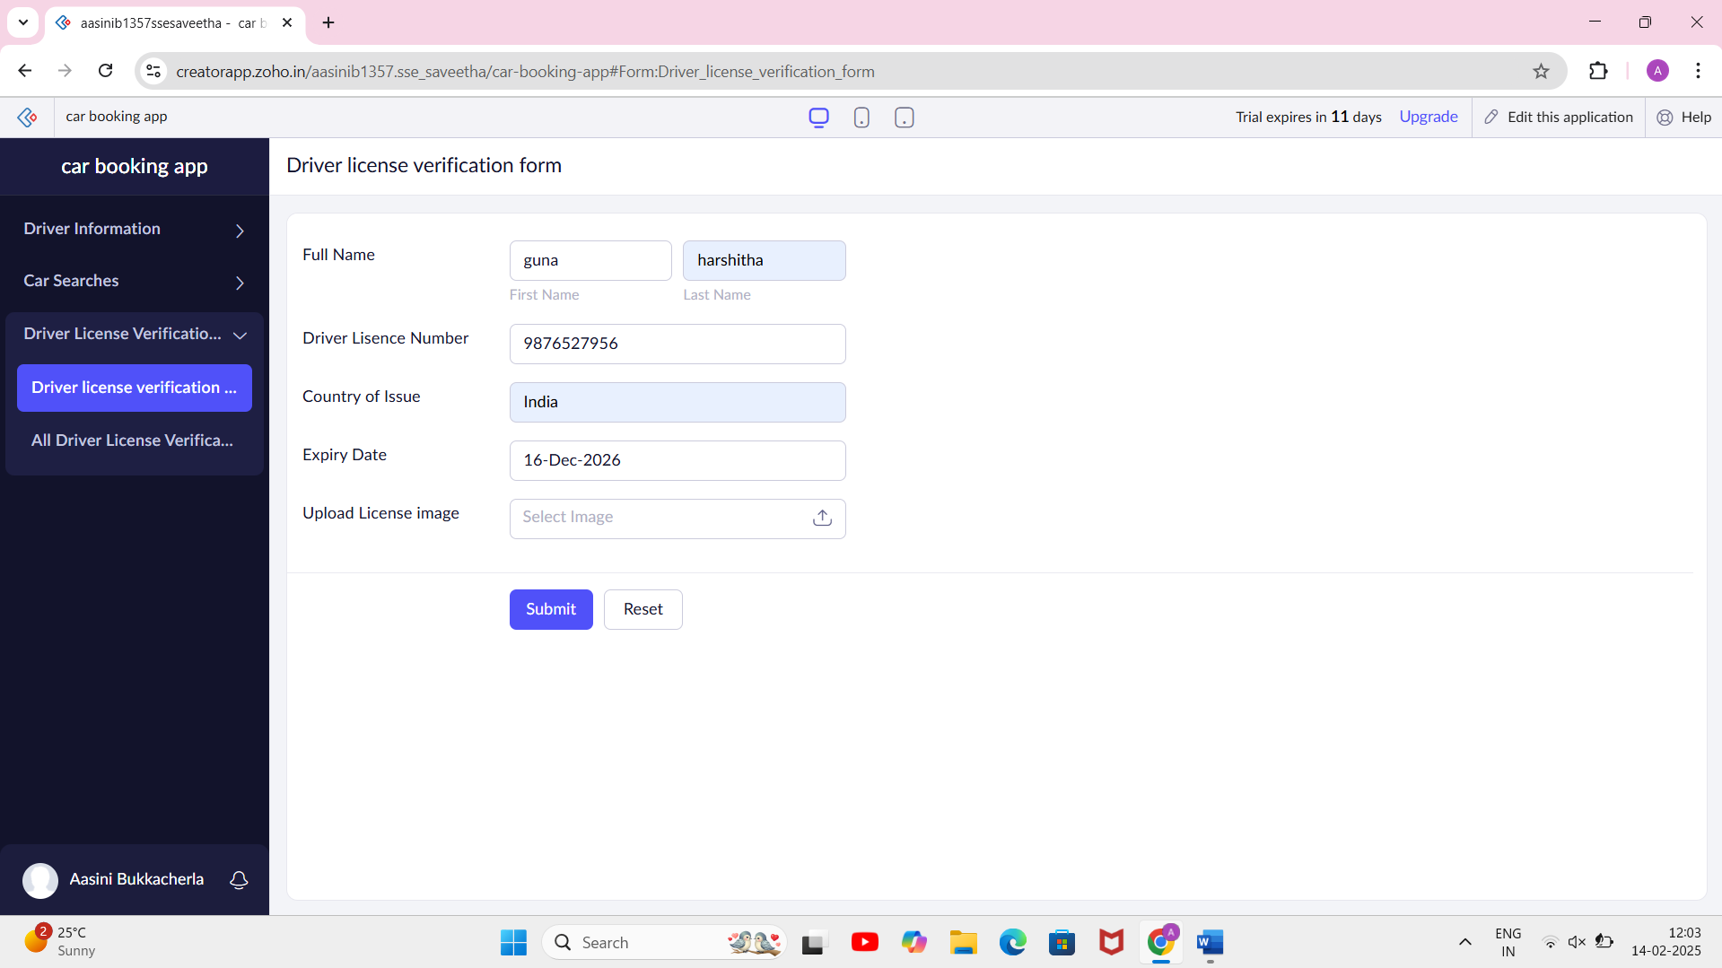

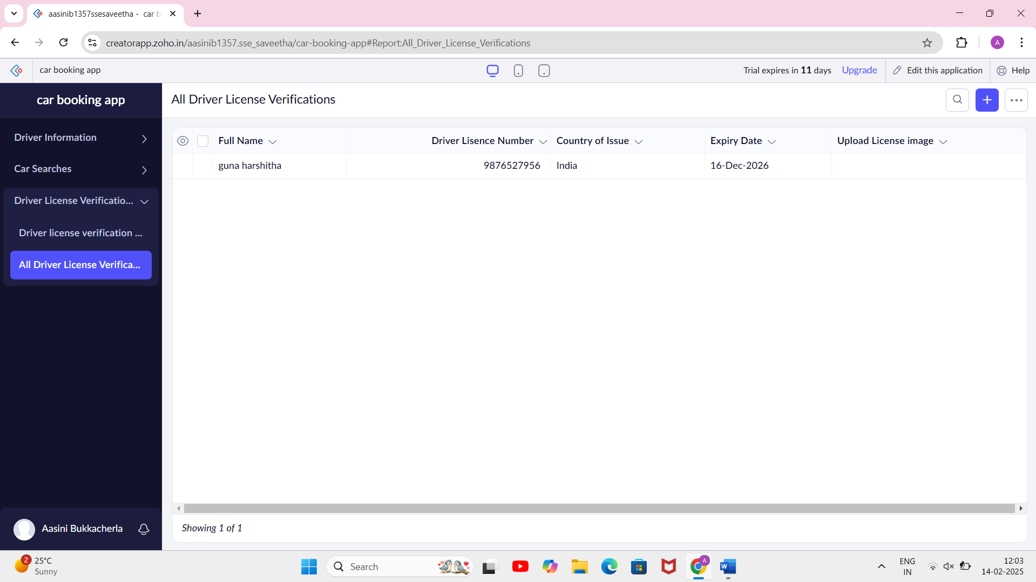

EXP NO 5:

CREATE A SIMPLE CLOUD SOFTWARE APPLICATION FOR LIBRARY BOOK RESERVATION SYSTEM FOR SIMATS LIBRARY USING ANY CLOUD SERVICE PROVIDER TO DEMONSTRATE SAAS.

AIM:

To Create a simple cloud software application for Library book reservation system for SIMATS library using any Cloud Service Provider to demonstrate SaaS

PROCEDURE:

step1: Go to zoho.com.

step 2: Log into the zoho.com.

step 3: Select one application step.

step4: Enter application name as library book reservation system.

step 5: Created new application as library book reservation system.

step 6: Select one form

step 7: The software has been created.

BOOK Isuance Form:

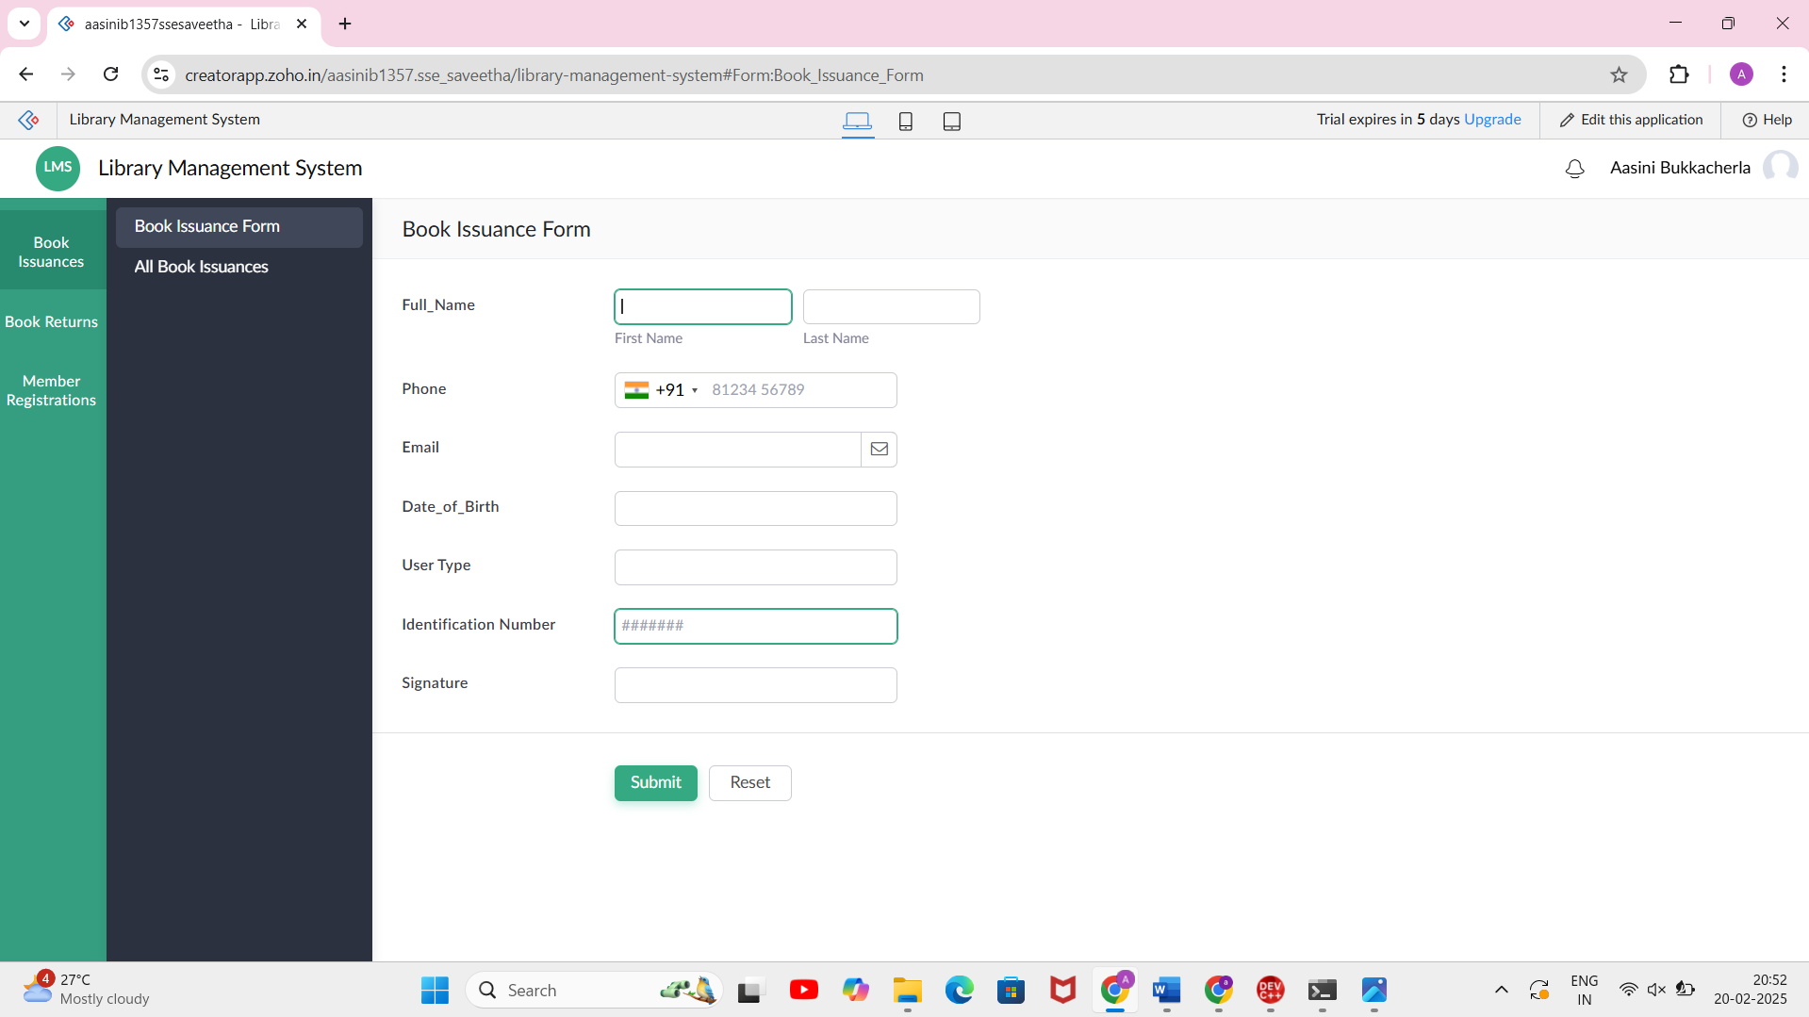

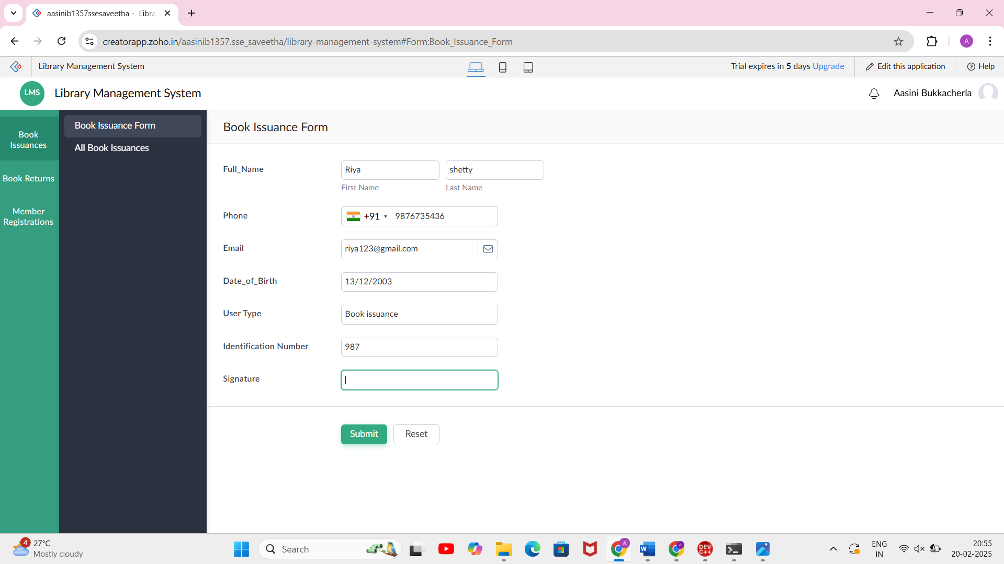

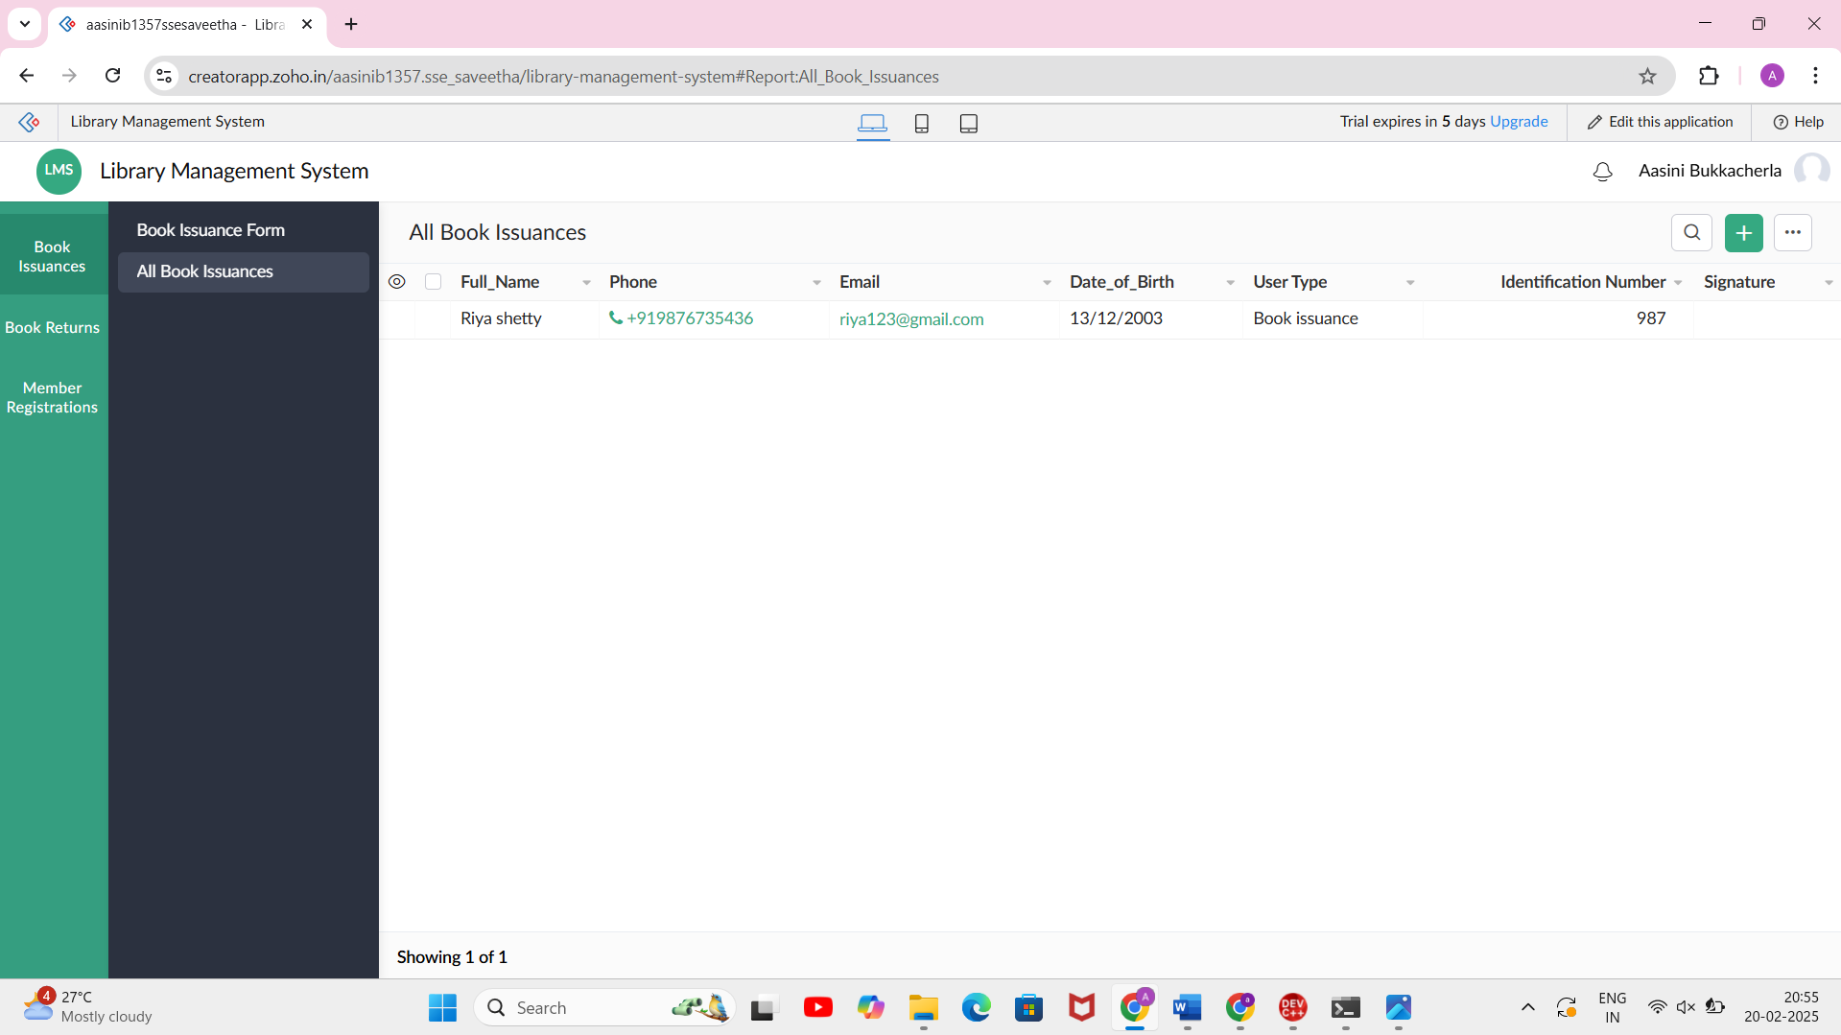

Book return form:

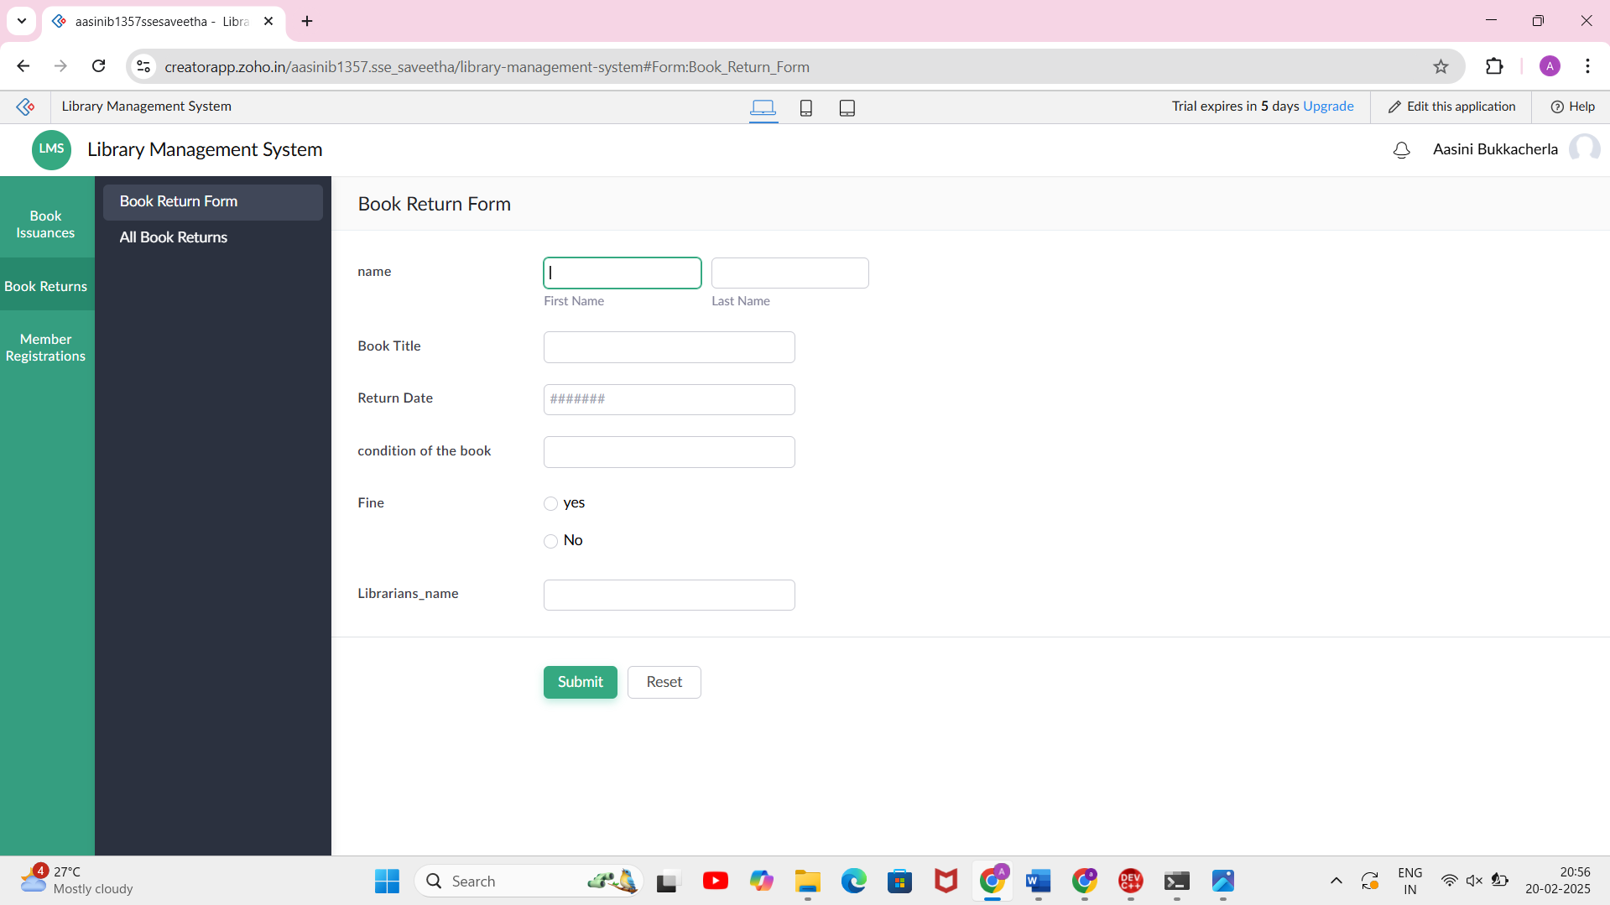

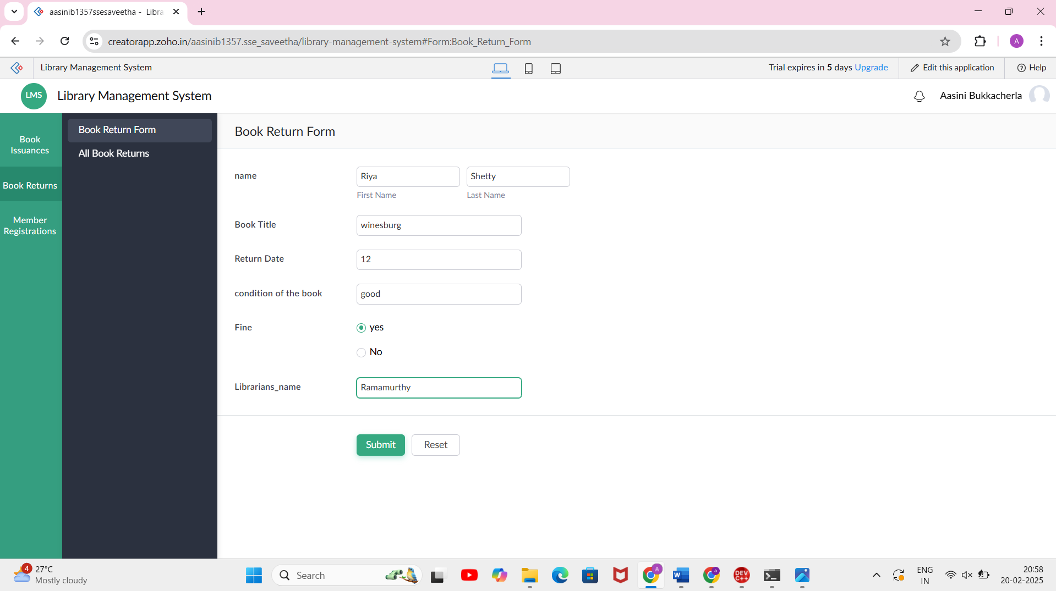

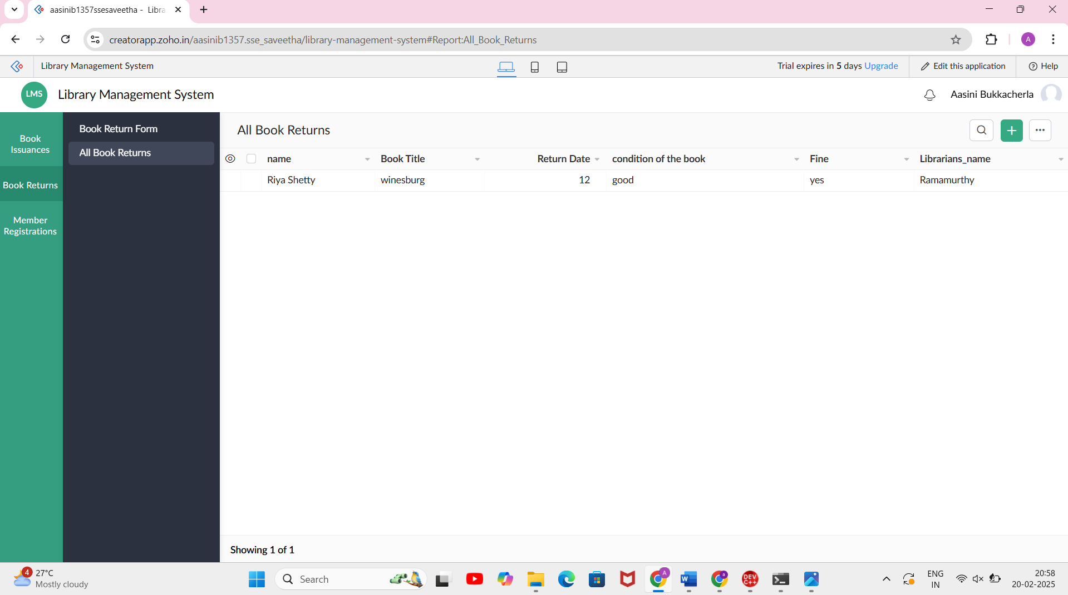

Member Registration Form:

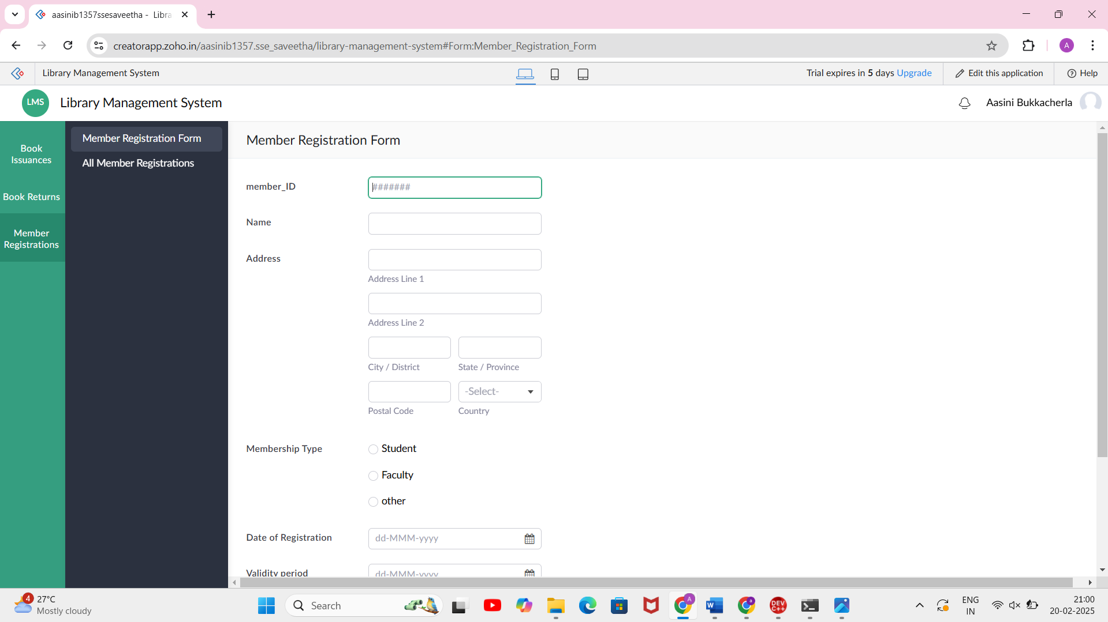

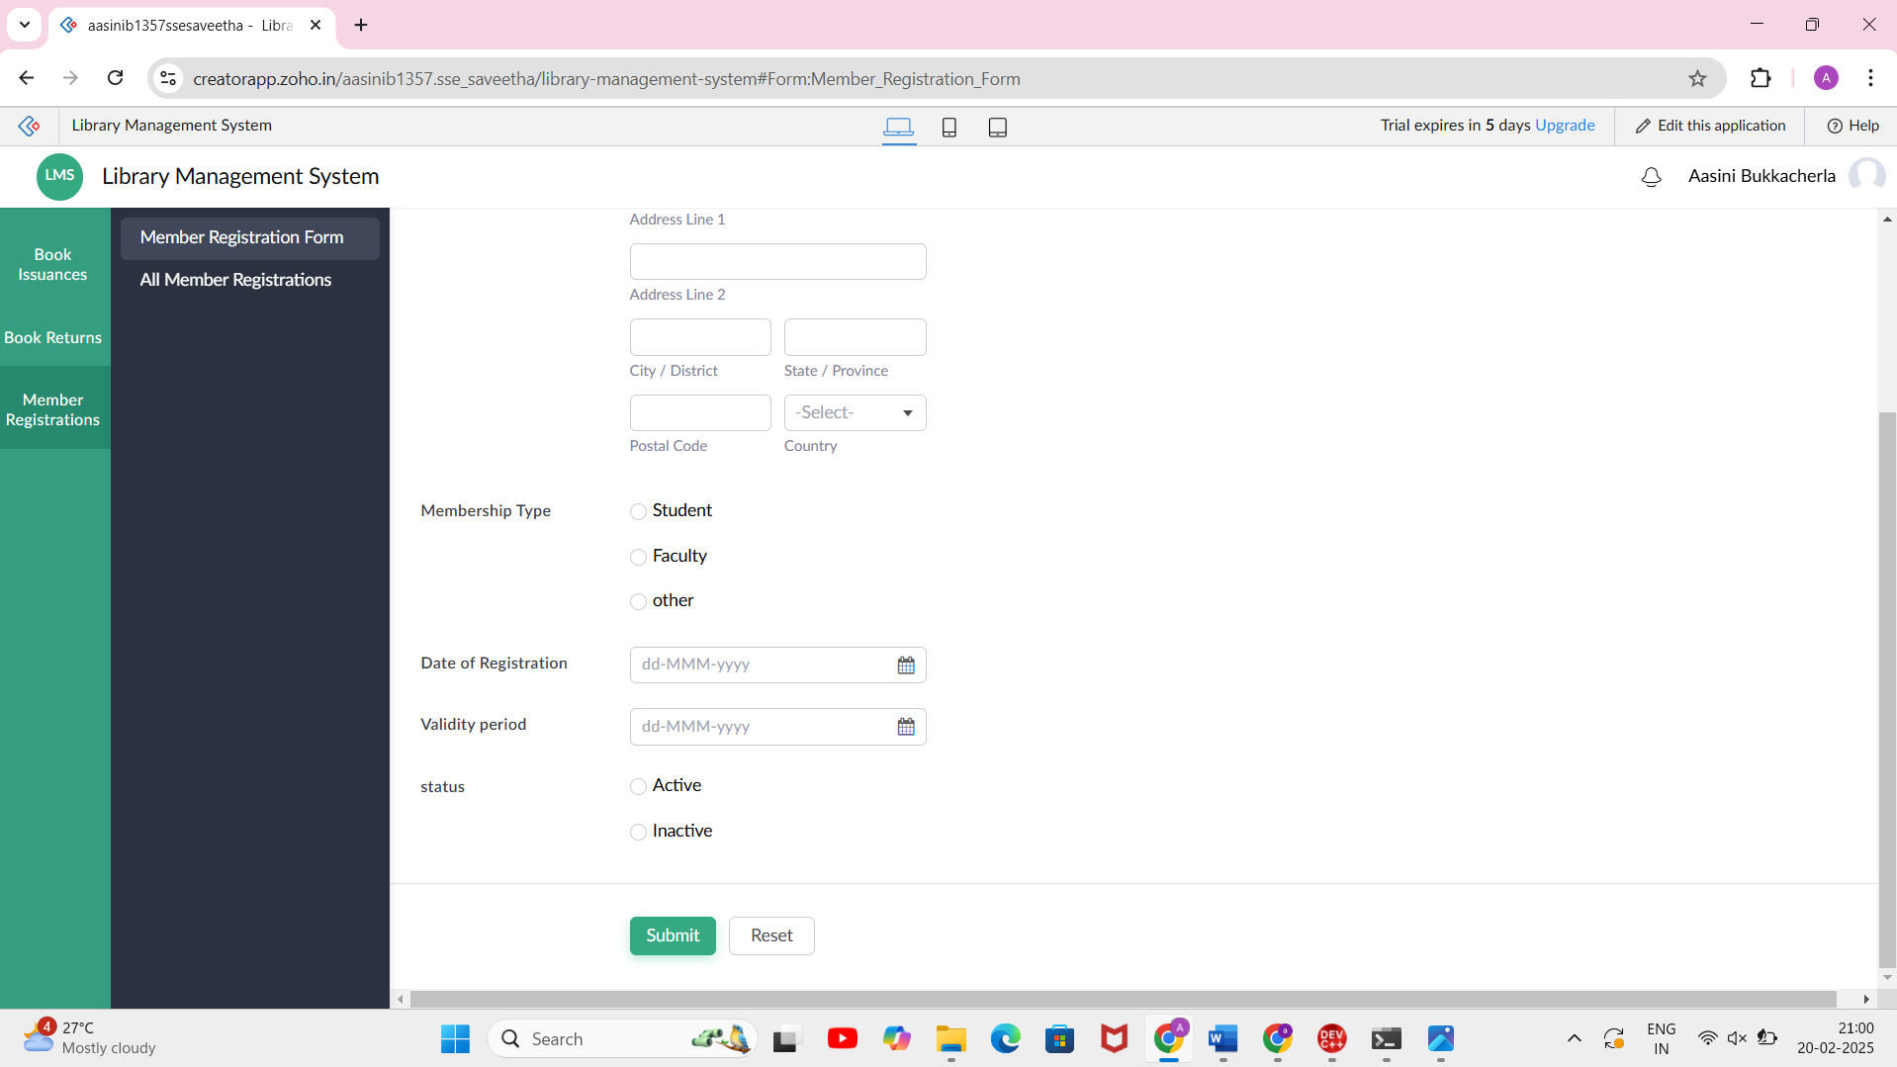

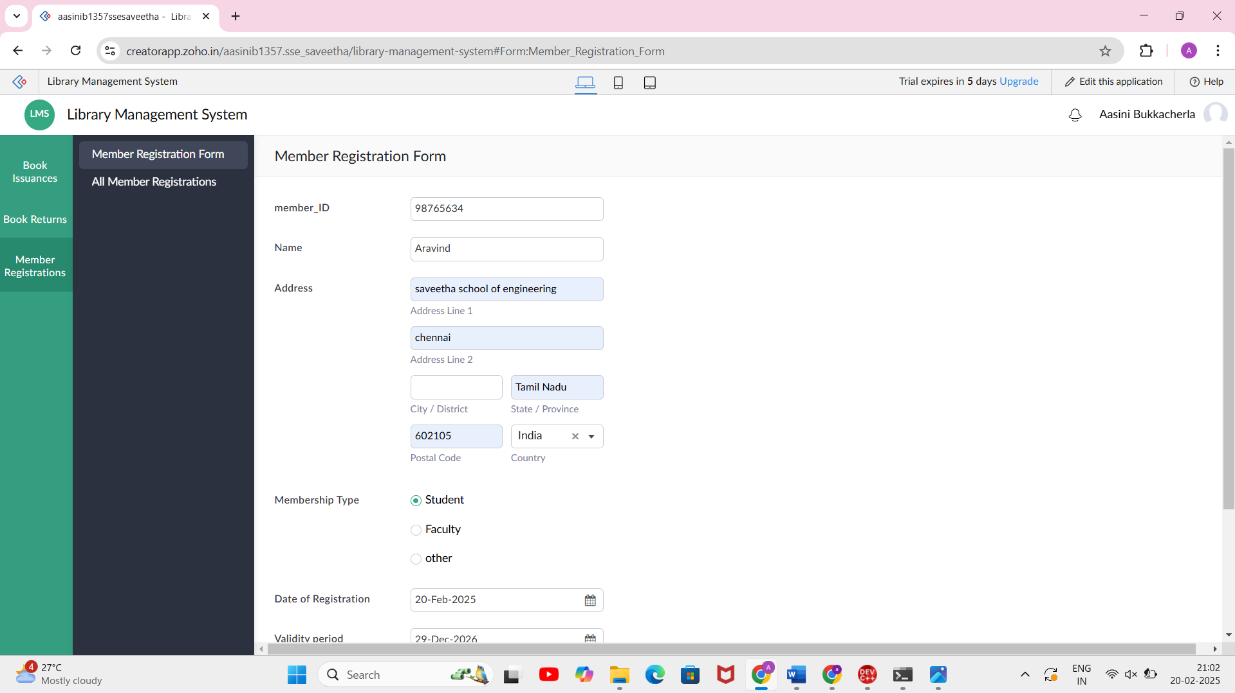

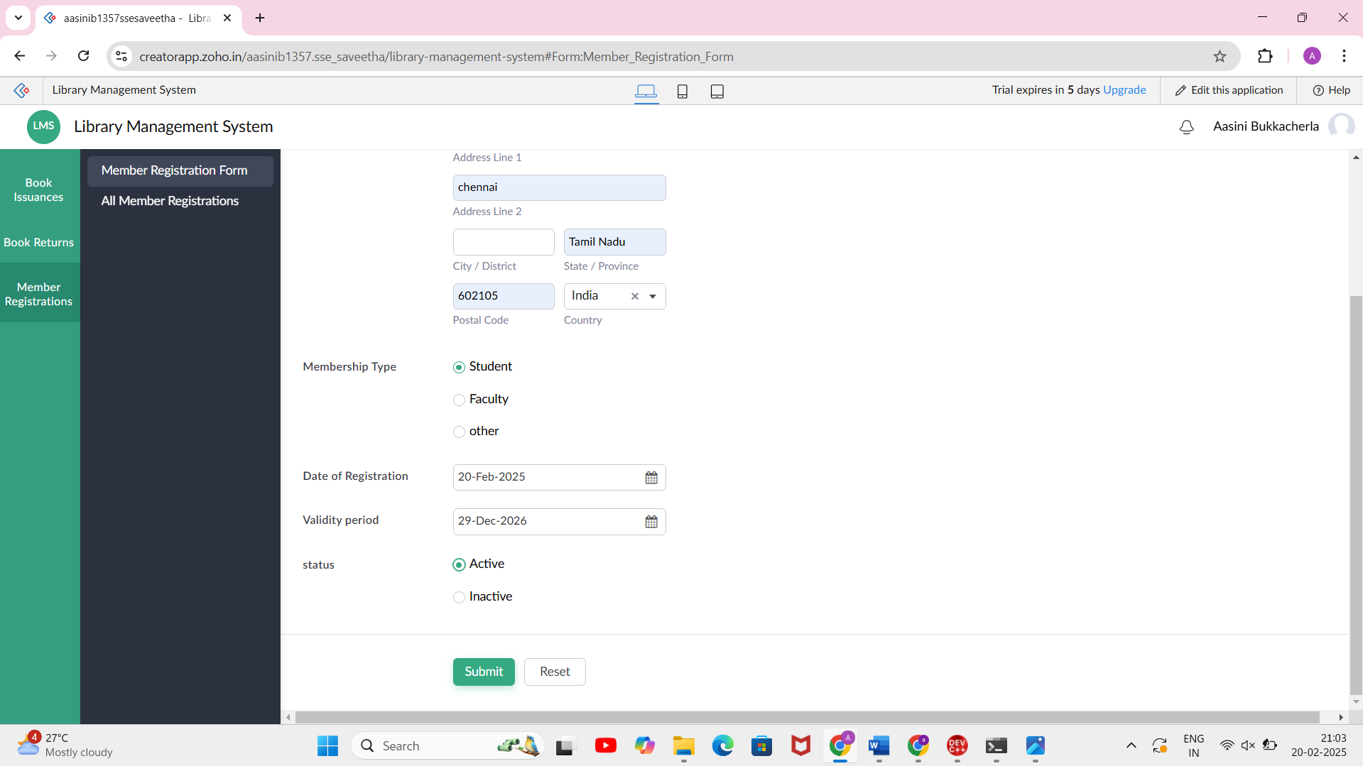

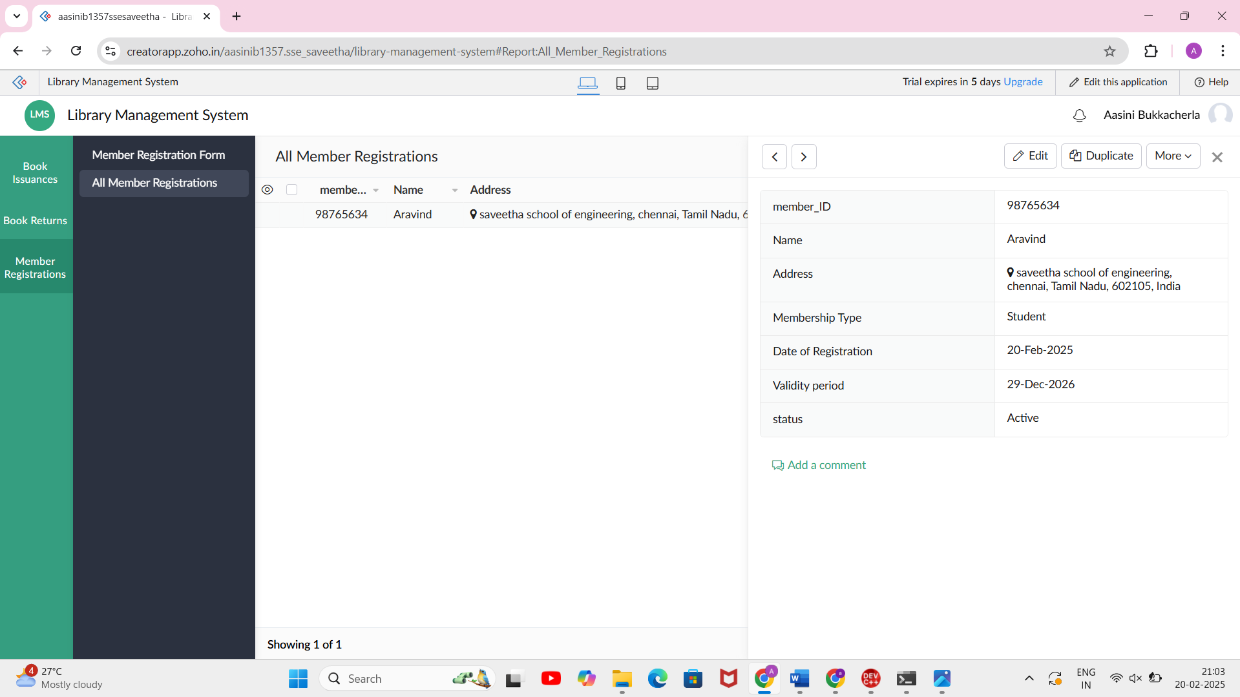

EXP NO 6: CREATE A SIMPLE CLOUD SOFTWARE APPLICATION FOR PRODUCT SELLING USING ANY CLOUD SERVICE PROVIDER TO DEMONSTRATE SAAS.

AIM: To create a simple cloud software application for product selling using any cloud service provider to demonstrate saas.

PROCEDURE:

step1: Go to zoho.com.

step 2: Log into the zoho.com.

step 3: Select one application step.

step4: Enter application name as product selling.

step 5: Created new application as product selling.

step 6: Select one form

step 7: The software has been created.

PRODUCT LIST FORM:

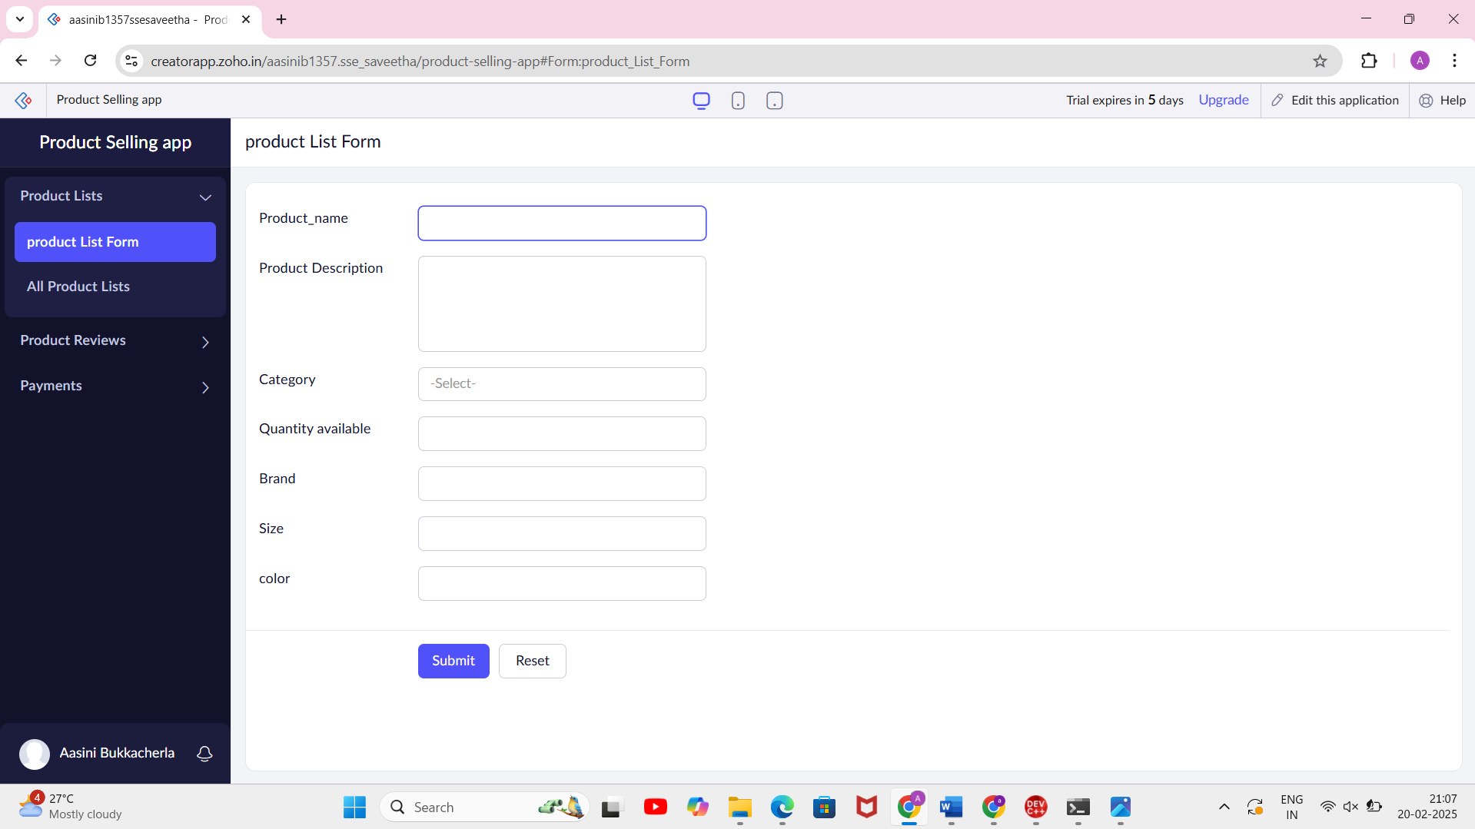

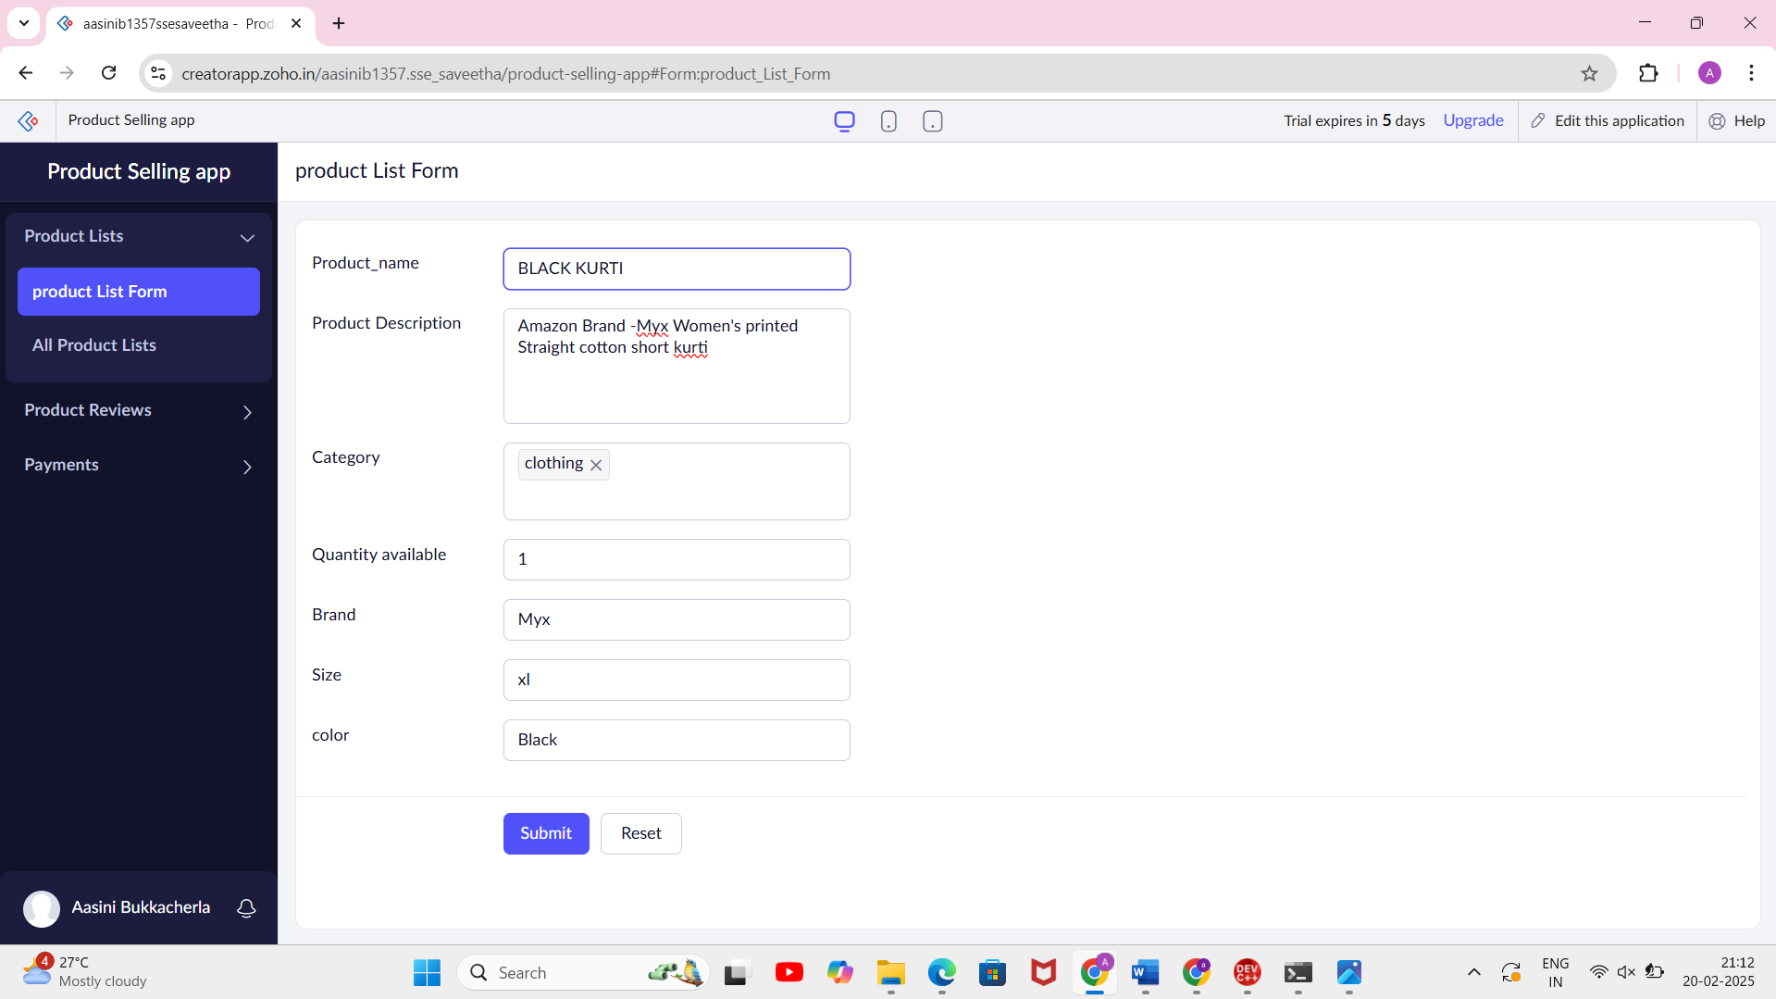

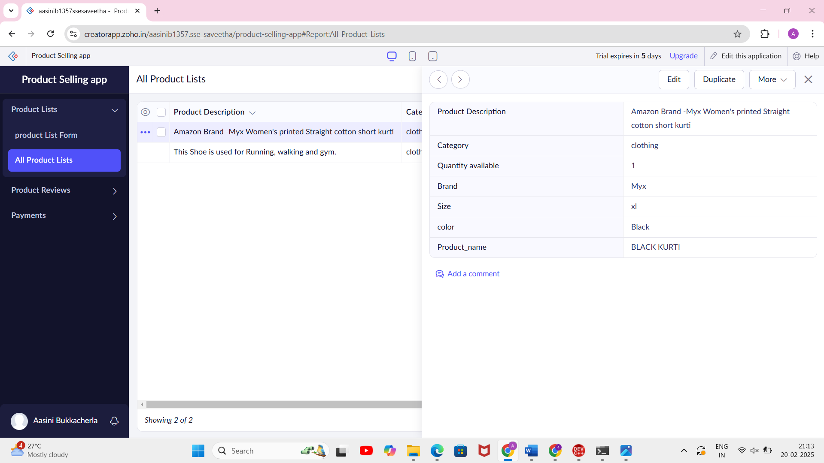

Product Review Form:

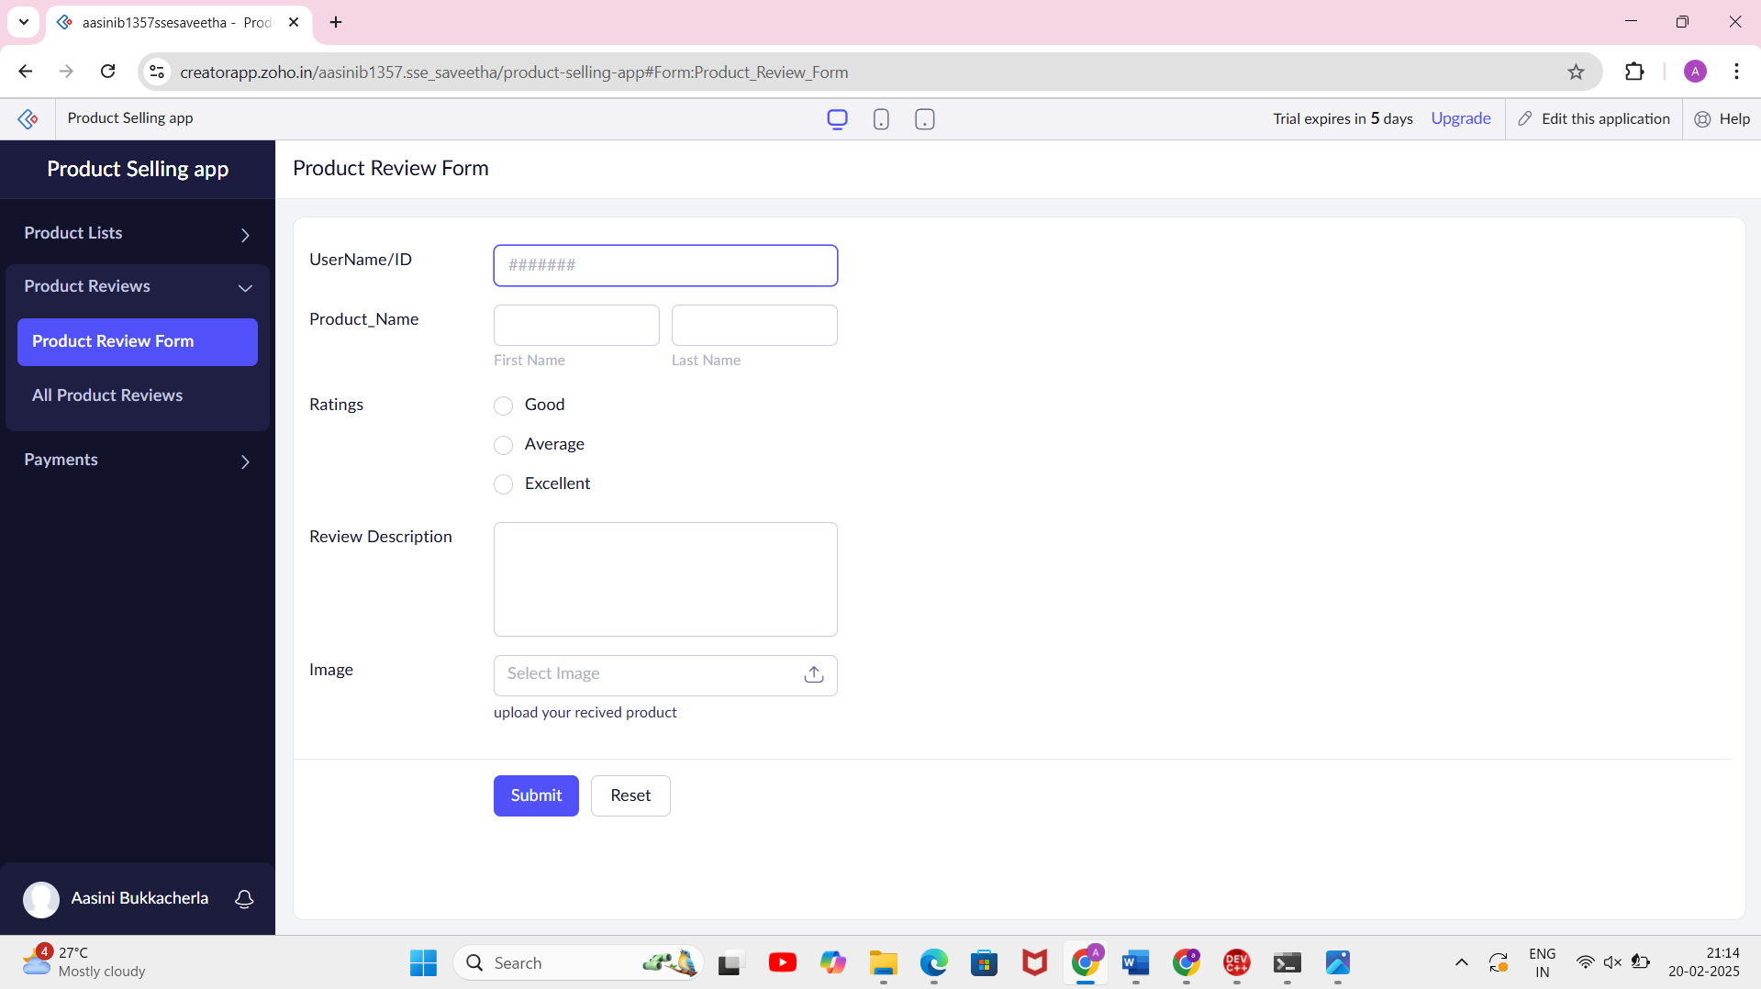

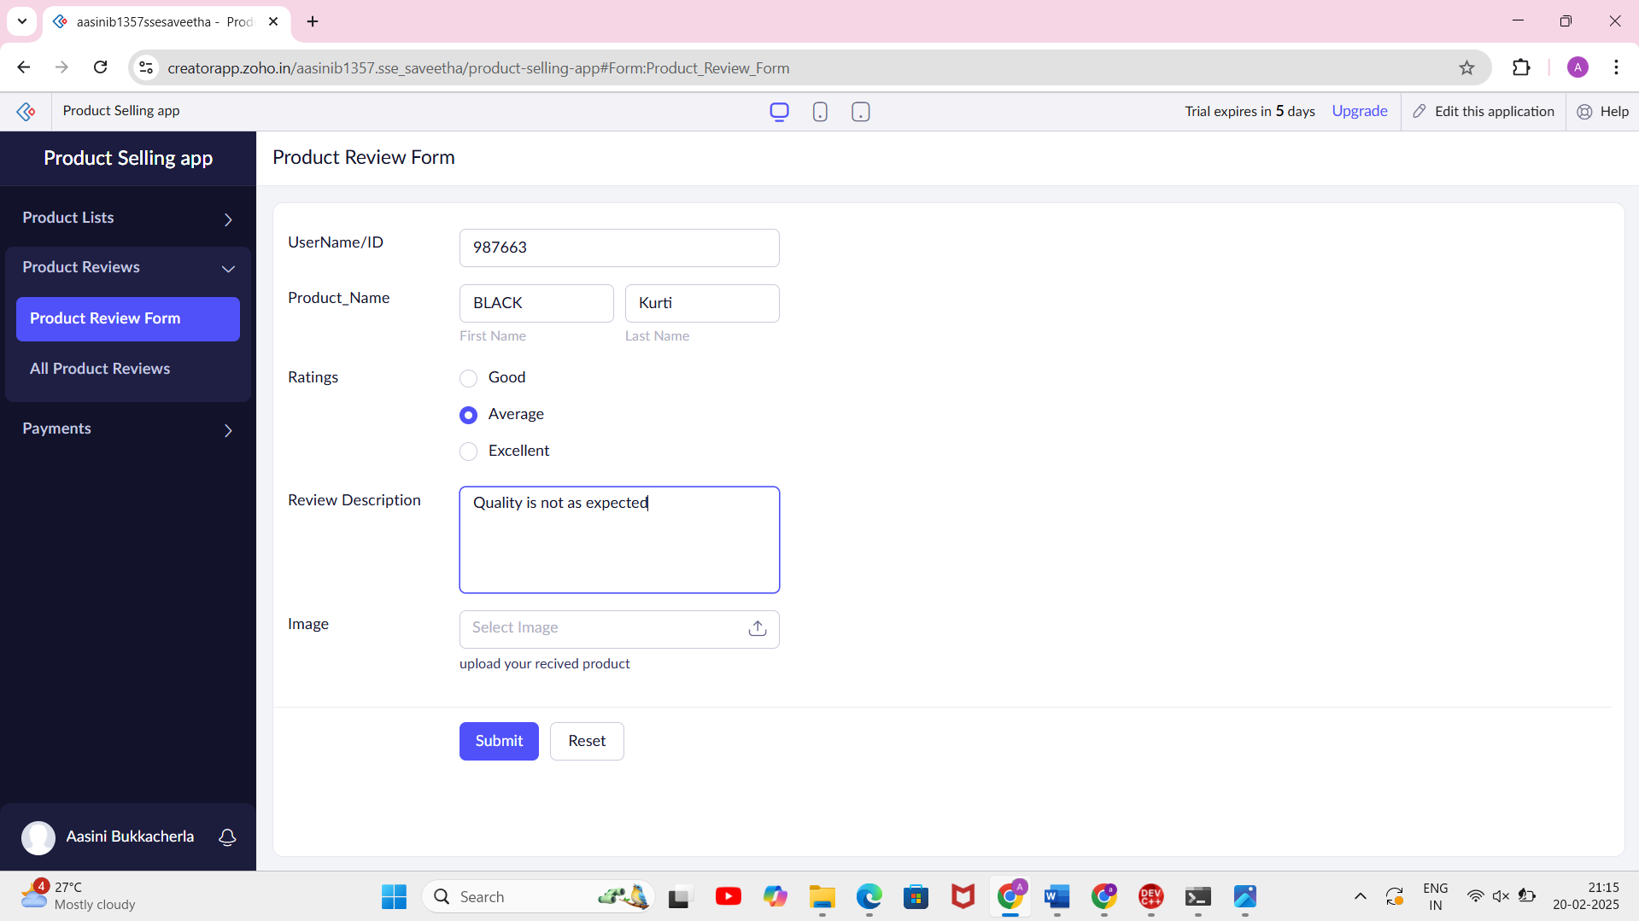

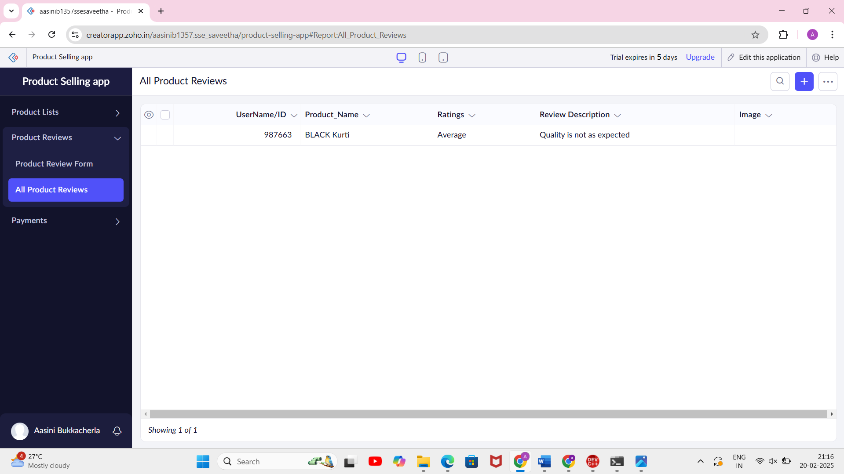

Payment form:

